Face Coverings for Worry Monsters
(& other creatures)

Knitting pattern by Debbie Cartwright

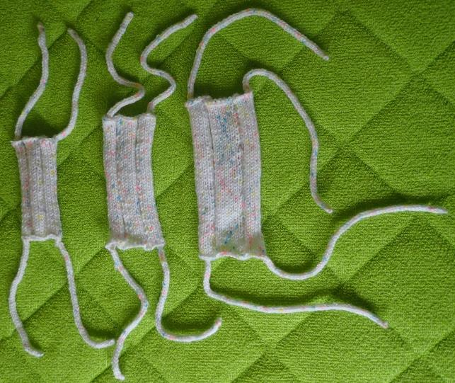

This pattern gives instructions for three sizes of face coverings for Worry Monsters, however the largest size is ideal for most monsters, therefore this is the size that Knit-for-Nowt has most demand for. The face coverings are designed to stretch to accommodate monster noses and they tie around the back of the head using knitted ties. The ties can be made flat using garter stitch or rounded using i-cords. The i-cord method uses two double pointed needles to produce a small knitted tube, with a similar appearance to French knitting.

Yarn
Double Knit yarn in any colour.
Quantity – 100g of acrylic DK should be enough for at least 5 large face coverings!

Needles
1 pair 4.0 mm (UK 8 / US 6) needles
If making i-cord ties, 1 pair 4.0 mm (UK 8 / US 6) double pointed needles

Gauge
Is not important because Worry Monsters come in various sizes and the face coverings are designed to stretch!

Abbreviations
k=knit
P=Purl

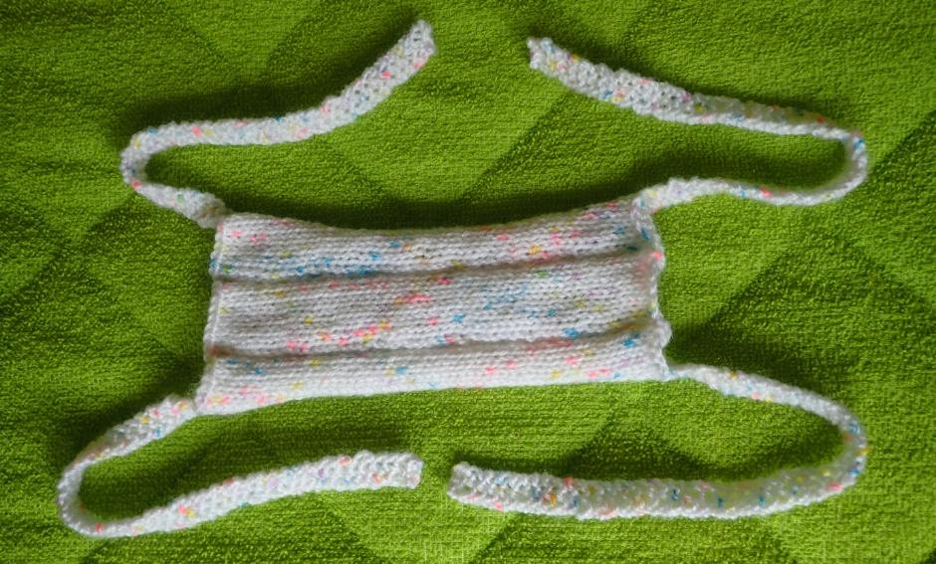

Large Face Covering
Cast on 32 stitches
1st Row (outside / front of mask): K1 P1 K7 P3 K8 P3 K7 P1 K1
2nd Row (inside of mask): P1 K1 P7 K3 P8 K3 P7 K1 P1
Repeat rows 1 and 2 until work measures 18cm, ending with row 2.
Cast off following stitch pattern for row 1.
Sew in ends.

Medium Face Covering
Cast on 28 stitches
1st Row 1st Row (outside / front of mask): K1 P1 K6 P3 K6 P3 K6 P1 K1
2nd Row (inside of mask): P1 K1 P6 K3 P6 K3 P6 K1 P1
Repeat rows 1 and 2 until work measures 16cm, ending with row 2.
Cast off following stitch pattern for row 1.
Sew in ends.

Small Face Covering
Cast on 25 stitches
1st Row 1st Row (outside / front of mask): K1 P1 K5 P3 K5 P3 K5 P1 K1
2nd Row (inside of mask): P1 K1 P5 K3 P5 K3 P5 K1 P1
Repeat rows 1 and 2 until work measures 11cm, ending with row 2.
Cast off following stitch pattern for row 1.
Sew in ends.

Ties
Recommended lengths for unstretched knitted ties are as follows:

Large Face Covering: 23cm per tie
Medium Face Covering: 18 cm per tie
Small Face Covering: 15 cm per tie

Garter Stitch method
With front / outside of the face covering facing you, use a straight needle to pick up 3 stitches around one corner of the face covering.

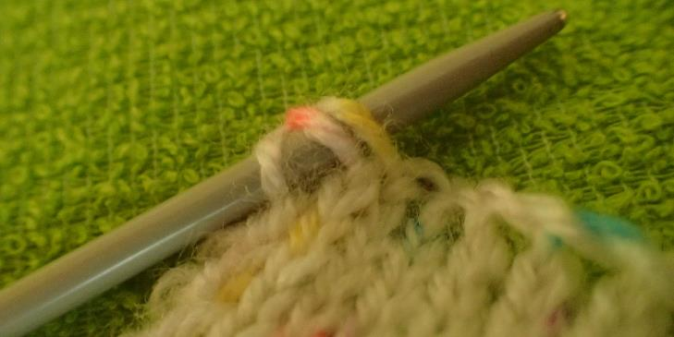

1st row: K3
2nd row: K3
Repeat this row until the tie is the desired length.
Cast off and sew in ends

Use the same method to make matching ties at the remaining three corners of the face covering.

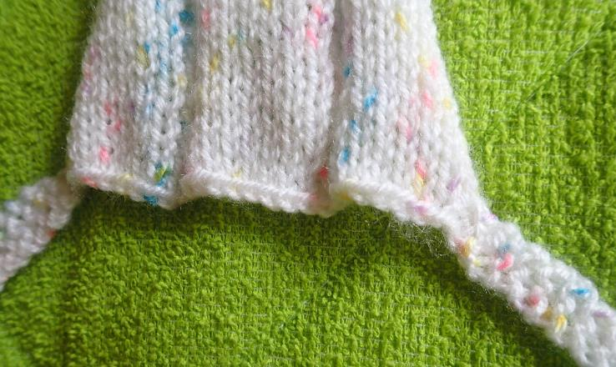

i-cord method
With front / outside of the face covering facing you, use a double pointed needle to pick up 3 stitches around one corner of the face covering.
Row 1: K3 (using the second double pointed needle).
DO NOT TURN WORK!
Row 2: slide the 3 stitches you have just knitted to the opposite end of the double pointed needle, ready to be knitted again. The working yarn will now be on the ‘wrong end’ of your knitting so pull it fairly tightly across the back of your work and use it to knit the 3 stitches again. This brings the left-hand stich closer to the right-hand stitch, forming a tube as the work grows.

Repeat Row 2 until the tie is the desired length (i.e by sliding the stitches along the needle instead of turning your work).

Cast off and sew in ends.

Use the same method to make matching ties at the remaining three corners of the face covering.

