Easy Animal Face for a

Crochet Worry Monster
For Knit-for-Nowt
http://www.knitfornowt.org

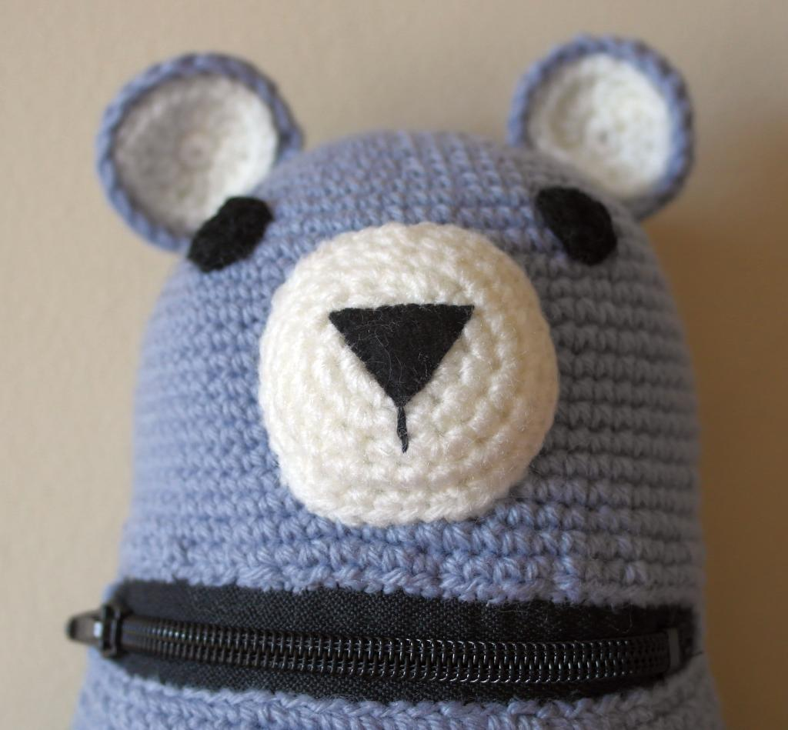
The following pattern shown on a body made to Phyllis's Crochet Worry Monster Pattern.

DK yarn
Sc = single crochet
Hdc = half double crochet

Eye
8sc into magic circle and pull tight.
or
Chain 3 and 8sc into first chain
Work another increase round for a bigger eye

Muzzle
If you know how to increase, start with 6sc into magic circle and increase up to 36 stitches.

6sc into magic circle
2sc into each stitch - 12
‘1sc, increase in next’ 6 times - 18
‘2sc, increase in next’ 6 times - 24
‘3sc, increase in next’ 6 times - 30
‘4sc, increase in next’ 6 times – 36

Add nose feature with embroidery or felt

Ears
Worked in 2 parts and 2 colours

Inner ear
- 6sc in magic circle
- Increase with 14 hdc into next round
- Increase with 18 sc into next round

Outer ear
- 6sc in magic circle
- Increase to 14 hdc into next round
- Increase to 21 hdc into next round
- Work 21 sc into next round

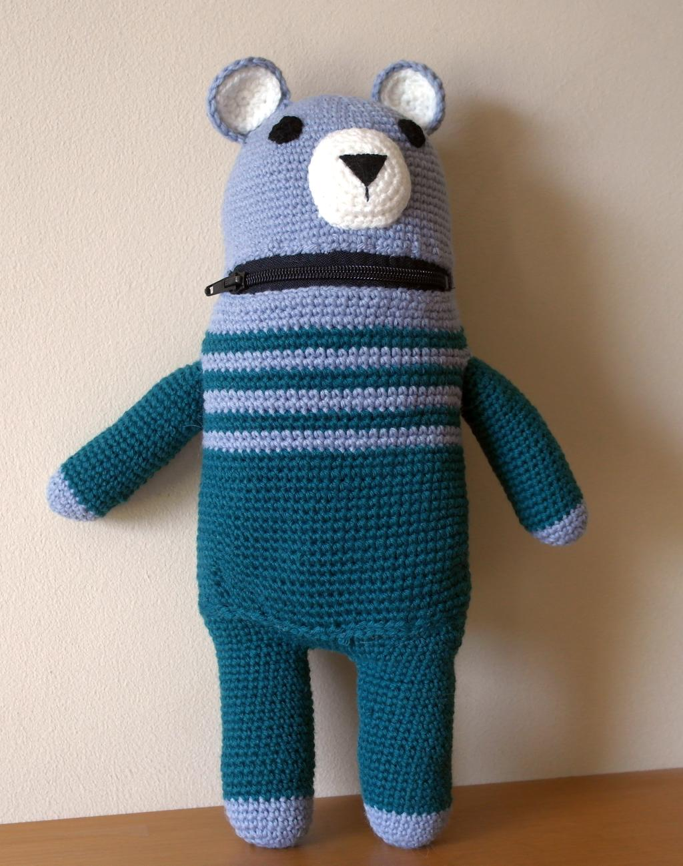

©2020 Phyllis at http://www.inky.work This guide may be used, reproduced, and reprinted only for charitable and personal use.

