KNITTED HAIR
A pattern for people who don’t mind knitting with more than one strand of yarn and sewing in extra ends.
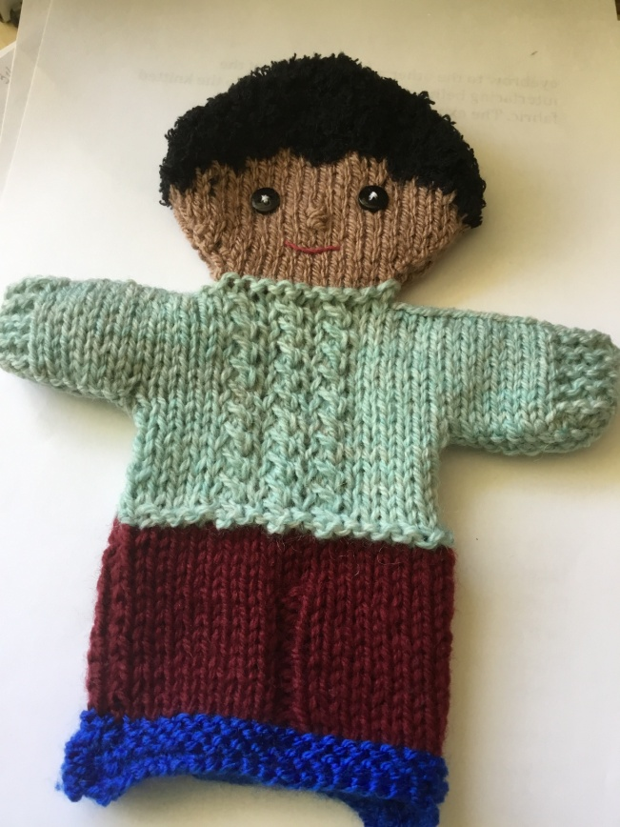
You can use this pattern either with ordinary hair coloured DK yarn, or use one of the brands of textured yarn designed for baby clothes and toys that do not have loose fibres. The following brands make good hair:
Sirdar Snuggly Snowflake: wuzzy (brown), beige and grey
Patons Fairytale Cloud: camel, chestnut
King Cole Cuddles: caramel
Phildar Phil Douce: (Aran weight, illustrated above; more expensive, but the only curly black yarn apart from alpaca) noir (black), souris (grey), anthracite (greybrown), grege (beige), givre (grey) taupe.
Stylecraft Eskimo, the best for straight shaggy black hair
One ball of yarn makes LOTS of hairdos.
If you’re lucky enough to go somewhere like Yarndale where there are specialist yarns, the natural coloured alpaca loopy yarns are just The Best for hair.

When knitting with two strands of yarn in the same row, the strands must be crossed at the back as you change from one colour to another, otherwise there will be a hole in the fabric. If you find this tricky you can knit the hair yarn and the face yarn together at the changeover point, always in the hair stitches. After all, we have hair and skin together.

Abbreviations;
Ss, stocking stitch: k, knit: p, purl: f, face yarn: h, hair yarn; k2tog, knit 2 stitches together; ws, wrong side; rs, right side; sts, stitches

Pattern:
Wind your hair yarn into two separate balls. Fuzzy yarn doesn’t carry well across the ws of the face, unless you want fluff showing through, so it’s best to work with two separate balls for each side of the face.
Follow the normal male puppet pattern until you have finished the increases at the start of the face and have 20 sts. and rs facing
Row 1 & 2: ss beginning with a k row
Row 3: (rs) k2h with first ball of hair yarn, k16f, k2h with 2nd ball of hair yarn
Row 4: (ws) p3h, p14f, p3h
Row 5: p5h, p10f, p5h
Row 6: (begin decreasing for head shaping) (k2tog k4)h, k8f, (k4, k2tog)h (18sts)
Row 7: at this point you can carry the hair yarn all the way across. P6h, p2f, p2h, p2f, p6h (18sts)
Here you can break off the face yarn and the hair yarn that is still in the middle. It’s handy to leave a long enough end of face yarn to carry down to sew the straight stitches for the nose, and should you want eyebrows, you can do the same with the loose end of hair. Grandad looks particularly good with bushy eyebrows.
Row 8: (all hair from now on) K2tog, k14, k2tog (16sts)
Continue in ss, decreasing one st at each end of every rs row until 12 sts remain, then one st at each end of every row until 6 sts remain, Cast off.

To add pigtails to a girl puppet, cut 4 strands about 4” long for each side, knot firmly in the middle and use one of the ends to sew firmly at ear level .
For Grandad’s bald head work up to row 6 then do one hair stitch less at either end of each row, keeping the head decreases correct.

This pattern was kindly donated to Knit-for-Nowt by Val in East Yorkshire.
