PATTERN FOR HAND PUPPET WITH STUFFED HEAD
(Adapted from Katherine Charles pattern of
Boy Hand Puppet with Hat)
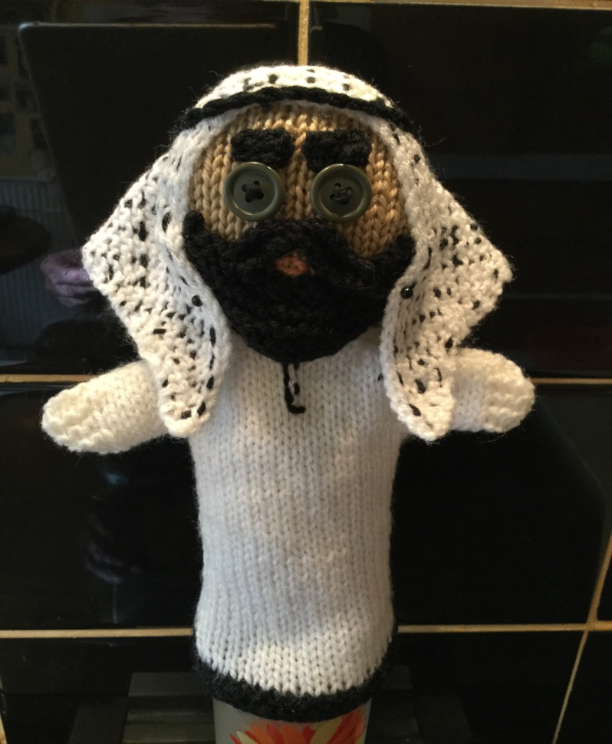
ISLAMIC DAD

You will need: Double knitting yarn in white and also black
4mm needles
Buttons for eyes, or sew-on type toy eyes
Abbreviations
SSK: Slip, slip, knit: Slip the first stitch as if to knit, slip the second stitch as if to knit, then slide the left hand needle into the front part of both stitches and knit them together.
M1: Make 1: Pick up and knit (or purl) the strand of yarn between the two stitches. Stitching into the back of this loop helps avoid a hole

Make 2 pieces.
Black Border:
Cast on 20 stitches
Knit 4 rows.
White robe:
Change to white yarn.
Stocking stitch (1 row knit, 1 row purl) until the robe measures 10 cms from the top of the border.

Arms:
1st arm row: Cast on 10 stitches, then knit across this row. (knit into the back of the first 10 stitches to make a tidier cast on)
2nd arm row: Cast on 10 stitches, k4, purl to last 4 stitches, knit 4. (Work into back of first 10 stitches)
Work another 8 rows alternating rows 1 and 2. On purl rows, knit the first and last 4 stitches.
Row 11: Cast off 14 stitches, knit 26 stitches (26 stitches)
Row 12: Cast off 14 stitches in purl-wise, purl 12 stitches (12 stitches)
Head:
Change to face colour
Row 1: Knit
Row 2: Purl
Row 3: K1, M1, K10, M1, K1. (14 stitches)
Row 4: P1, M1, P12, M1, P1. (16 stitches)
Row 5: K1, M1, K14, M1, K1 (18 stitches)
Row 6: P1, M1, P16, M1, P1 (20 stitches)
Continue in stocking stitch (1 row knit, 1 row purl) until head measures about 4.5 cms.
Decrease for top of head:
Row 1: K1, SSK, knit to last 3 stitches, K2 tog, K1
Row 2: Purl
Repeat these 2 rows until 8 stitches remain. Cast off.

Head Linings (Make 2)
Cast on 12 stitches, then follow instructions for head, as above.

With right side facing, sew buttons for eyes, about half way down the head of one main piece:

With right sides together, pin linings to head pieces, and backstitch together close to the edge, leaving neck edge open.

Turn heads right side out and stuff lightly – please ensure that you only use stuffing that has a BS or CE label on the packaging, thank you.
Turn over and slip stitch neck edge closed on both pieces. Make sure there are no gaps for stuffing to escape!
Sew rest of body pieces together.
To finish face:
Beard:
Black yarn.
Cast on 2 stitches.
Working in garter stitch, (knit every row), increase 1 stitch at each end of every row until you have 24 stitches.
Next row: K4, (K2 tog) to last 4 stitches, k 4. (16 stitches)
Knit 1 row.
Cast off loosely.
Moustache:
Cast on 12 stitches.
Knit 1 row.
Cast off. Tie a piece of yarn tightly around centre of moustache.
Eyebrows:
Cast on 5 stitches. Cast off.
Pin pieces to face and backstitch in place. Sew all ends into the stuffing
Headpiece
White yarn.
Cast on 2 stitches.
Knitting in garter stitch, increase 1 stitch at the beginning of every row until you have 60 stitches on your needle. You should have a perfect triangle! Cast off loosely.
Head pieces are traditionally black and white or red and white check, but they can be plain white too.
To create a check effect, do black or red running stitches vertically and horizontally on the triangle piece. Pin head piece to puppet, then sew in place around the edge of the face.
Make a black, twisted cord and sew in place around the head piece.
Libby, March 2017
Scroll down for photos to show workings

Note from Clare at Knit-for-Nowt: please ensure that for safety all pins have been removed – it seems so obvious but it’s amazing how it easy it is to miss one!

EXPLANATION OF STUFFING THE HEAD USING HEAD LININGS

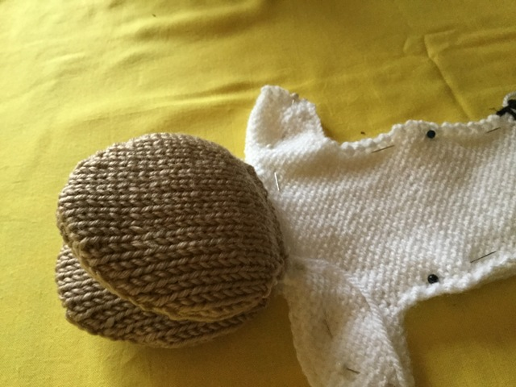

Stuffing the head in this way prevents any stuffing being able to get out, therefore making it safer with children in mind.
Instead of making just 2 pieces for the head you make 4. And 2 of those are referred to as the “Head Linings”
You sew them together into 2 pairs, stuff each one separately and then sew up the bottom edges so the stuffing is completely enclosed in each one.
You now have 2 separate little padded pieces –The “Head Lining” is therefore referring to the 2 inner parts (which in this pic looks like the insides of an open mouth). Now attach the bottom of one padded piece to the top edge of the puppet front, and the other padded piece to the top edge of the puppet back.
Sew the 2 padded pieces together at the edges, this time leaving the bottom open so you can then get your fingers in the head, and there will be a stuffed pocket either side of your fingers. The rest of the puppet is sewn together (unstuffed) as normal.

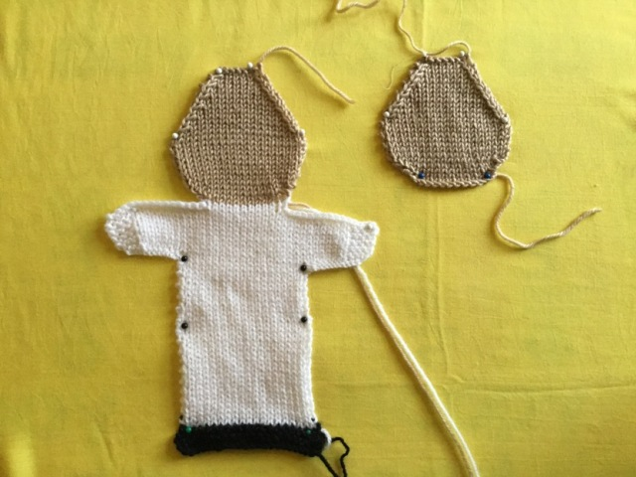

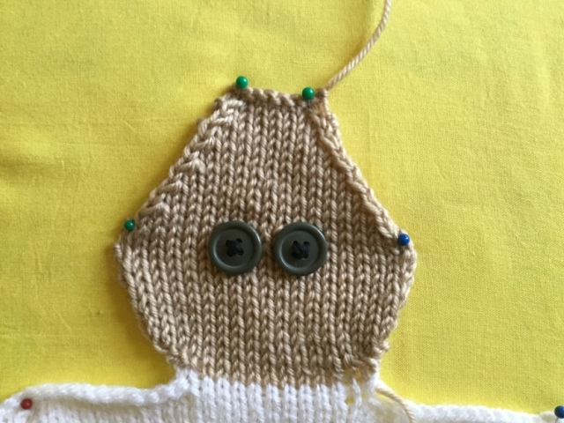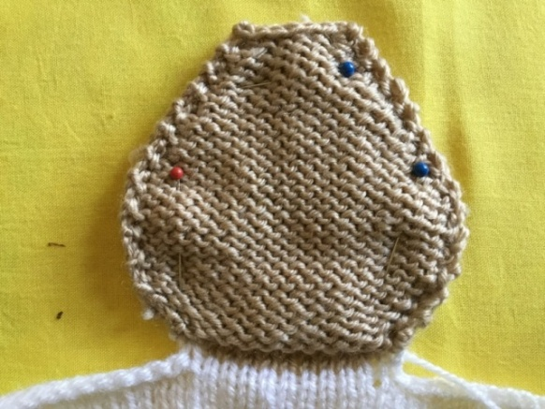

Sew beard, moustache and eyebrows in place

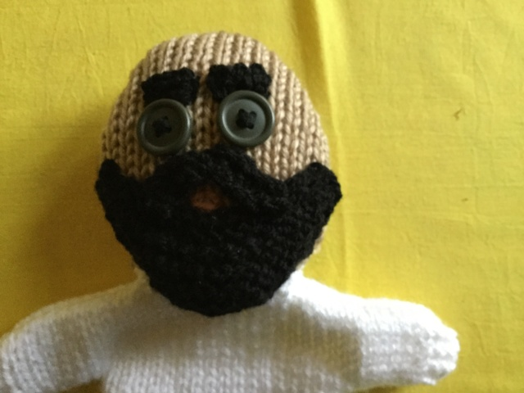

Back view of headdress

|