Phyllis’s Pattern to

Crochet a Worry Monster
for Knit-for-Nowt
http://www.knitfornowt.org

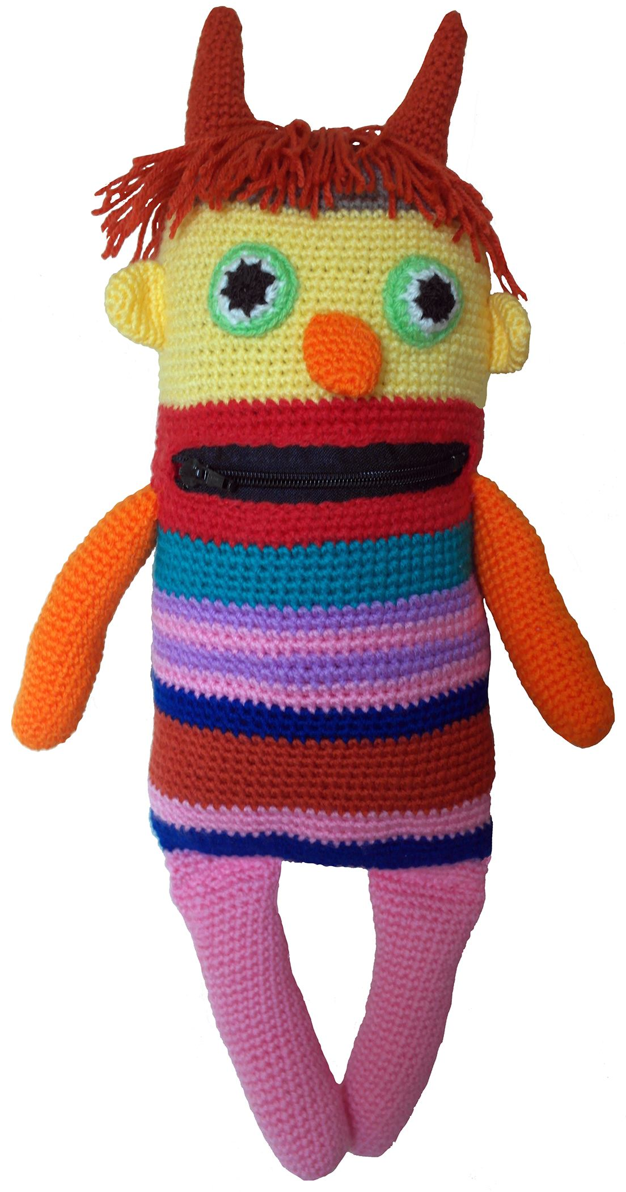

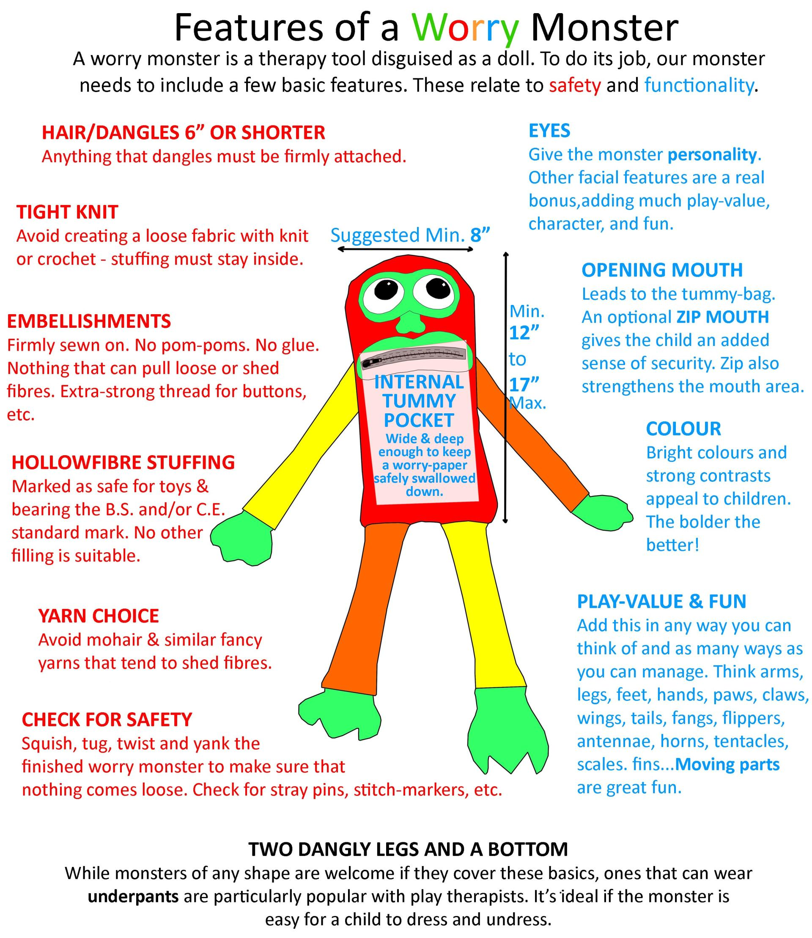

YOU WILL NEED

FOR THE CROCHET
- DK yarn in bright colours. We’ve had success with Pato DK, Sirdar Snuggly DK, and Stylecraft DK, all of which come in a range of vibrant colours.
- 3.5mm crochet hook
- Stitch markers
- Scissors
- Wool sewing needle
- Optional: Sewing thread and hand-sewing needles.

FOR THE ZIP MOUTH AND TUMMY-POCKET
- 5” closed-end zip. Chunky is ideal but a standard skirt-zip will fit.
- Polyester “liquid” satin or other strong, lightweight, non-stretch fabric for the tummy-pouch. (We could crochet an inner pocket, of course, but we haven’t found a way to stop the crochet getting caught in the zip.)
- Measuring tools (or cut by eye using monster body as a guide)
- Cutting tools
- Sewing machine or sharp hand-sewing needle
- Sewing thread
- Pencil or chalk to mark fabric.

Phyllis’s

BASIC WORRY MONSTER

CROCHET PATTERN

Sc = single crochet
Inc = increase
DK yarn on a 3.5mm hook

- 6sc in magic circle (or ch3 and 6sc into 1st st)
- 2sc in each st (12)
- *2sc, inc in next* x 6 (18)
- *3sc, inc in next* x 6 (24)
- *4sc, inc in next* x 6 (30)
- *5sc, inc in next* x 6 (36)
- *6sc, inc in next* x6 (42)
- *7sc ,inc in next*x 6 (48)
- *8sc, inc in next* x6 (54)
- *9sc, inc in next* x 6 (60)
- *10sc, inc in next* x 6 (66)
- *11sc ,inc in next* x6 (72)
- *12sc, inc in next* x 6 (78)

The above rows are worked in a spiral.

From now on work with a seam at the back of the shape in order to place the mouth/zip hole correctly.

(NOTE: The basic crochet stitch would be at end of round slip stitch into 1st stitch of next round and ch 1. A neater way to make a seam changes the normal use of even tension but makes a less-visible seam. At the end of round slip stitch into 1st stitch of next round, pull down tight, chain 1 and pull down tight, then sc1 into same hole at normal tension.)

Work 18 rows on 78scs.

Place two stitch markers to show how large the mouth/zip hole you need.

Crochet from back seam to 1st marker, TURN work and crochet back to 2nd marker, TURN work and crochet back to 1st marker, chain same number of stitches to fit the hole between markers, rejoin and continue on.

Work approx. 35 more rows to reach at least 12” head/body length. (Optional: Continue up to the maximum of 17” for head/body requested by Knit-for-Nowt, to fit inside their shipping boxes.)

Decrease some stitches, maybe 12/15, in the last couple of rows to give a bit of shape to the bottom.

Matching the increase system at the top of the pattern, make arms and legs the width/length you want. Working spiral rows will not give a perfectly straight arm/leg, so use a straight seam join if this bothers you (though monsters probably don’t care about twisted legs!)

FACIAL FEATURES & EMBELLISHMENTS
Features like horns, eyes, noses, etc. can all be crocheted. I-cord makes good lips and eyebrows. Or try adding embroidery or felt shapes. Pinterest and YouTube are great places to find free patterns/instructions on how to make good shapes, and the internet has plenty of monster pictures to help find new ideas.

The Knit-for-Nowt website – http://www.knitfornowt-org – links to some great ideas for eyes and for safely adding hair.

Everything must be firmly sewn on. No glue.

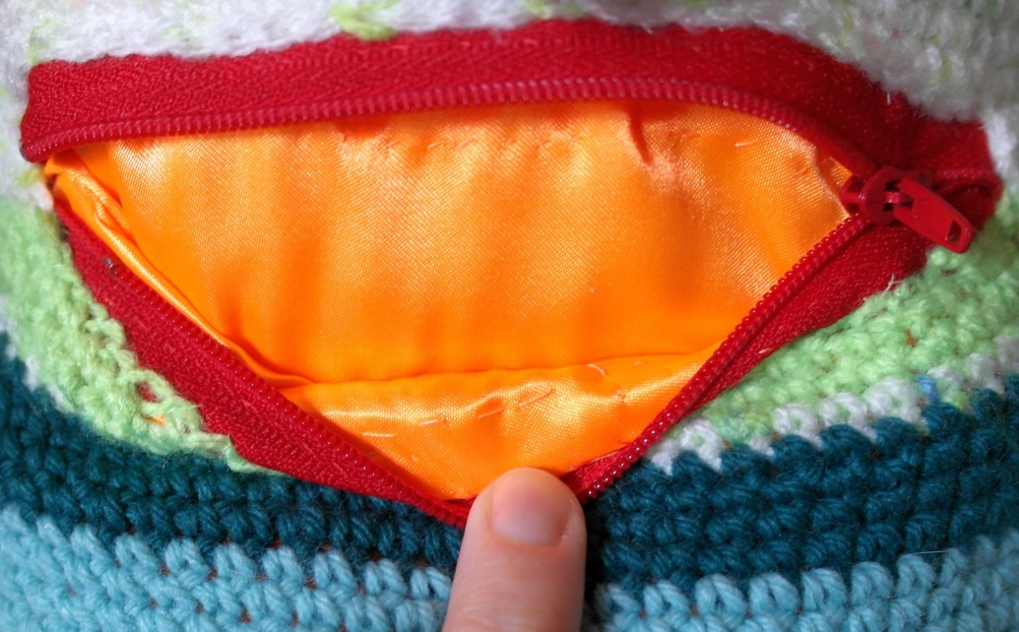
ADD A ZIP MOUTH
If you need some help with this step, see Inky Work’s guide to adding a zip mouth to a knit/crochet worry monster on the Knit-for-Nowt website.

This crochet pattern was designed around a 5”, closed-end zip. Zip is sewn behind the mouth hole and ends up sandwiched between the crochet and the tummy-bag.

ADD THE TUMMY-BAG
If you need help with this step, see Inky Work’s guide to adding a fabric tummy to a knit/crochet worry monster on the Knit-for-Nowt website.

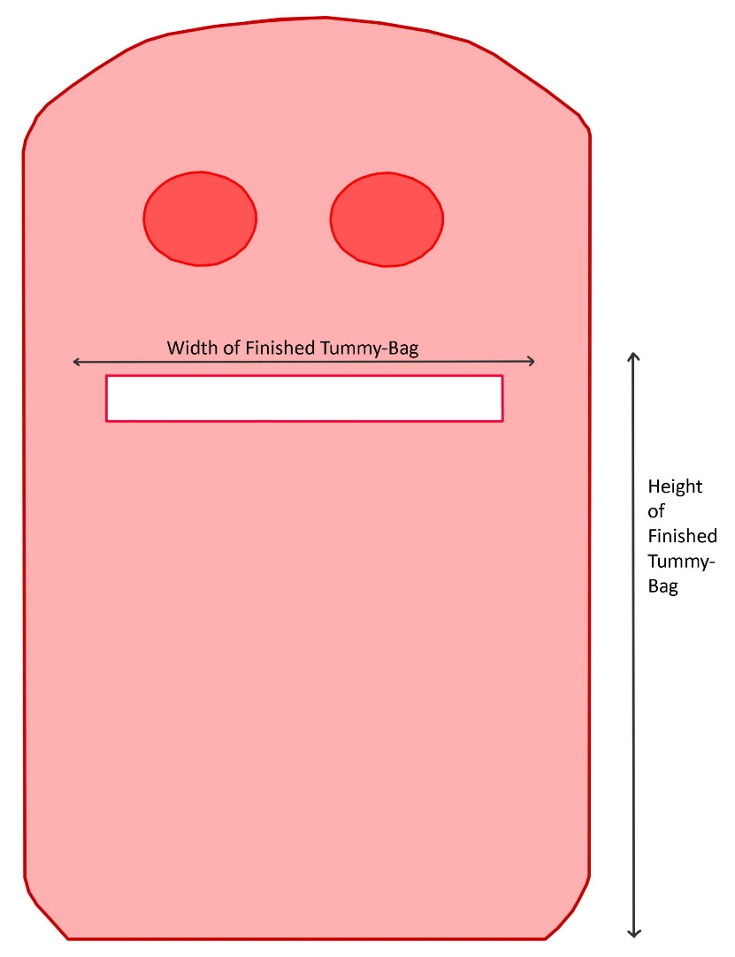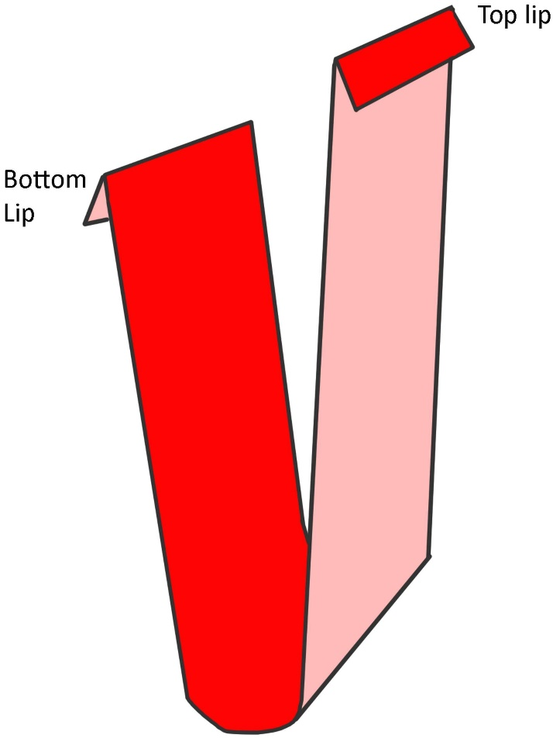

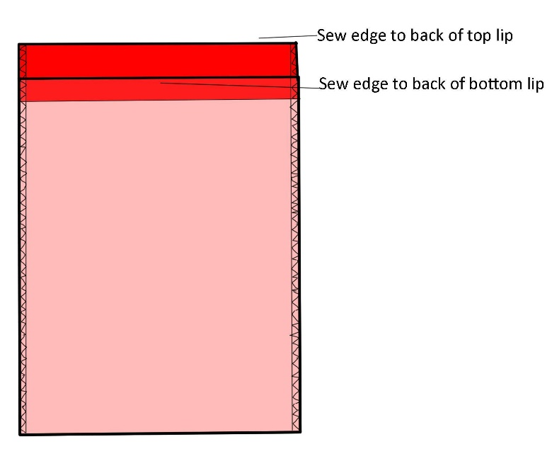

STUFF THE PIECES
Take a moment to make sure that the tummy bag is lying flat against the crochet. We want to put stuffing behind it.
Use hollowfibre stuffing, from packaging marked as suitable for toys and bearing the B.S. and/or C.E. standard mark. Stuff each lined piece of the monster, adding small amounts of stuffing at a time to avoid lumps and voids. Take care not to stretch the crochet too much – we don’t want to spoil that beautiful work or make any holes big enough to leak stuffing.
Check that you can still fit a folded piece of paper into the mouth/tummy after stuffing.

SEW THE MONSTER TOGETHER
Arms, legs, any other sticky-out bits such as wings or fins - as with embellishments, these all need to be tightly attached. Some pieces might be more easily attached before another part is stuffed or sewn shut. Look at the pieces and think the process through before you begin, working out what order would be best for your monster.
This pattern assumes a flat top to each limb where it joins the monster body, but it’s not too difficult to make the joins 3-dimensional.

CHECK EVERYTHING ONE LAST TIME
- Pull, tug, and twist everything – the limbs, the embellishments, any seams. Nothing should feel loose.
- Squish the monster between your hands to make sure that no pins or stitch markers are left in there.
- Check there are no stuffing leaks.
- Check that the zip works.
- Slip a hand into the tummy-bag and check that it’s open all the way down.

CONGRATULATIONS, IT’S A WORRY MONSTER!
Get in touch with Knit-for-Nowt about donating your monster(s).
https://www.knitfornowt.org/contact_us
Thank you for supporting this wonderful charitable scheme. Your monster will make a lot of difference to the lives of troubled children.

©2020 Helen at http://www.inky.work

This guide may be used, reproduced, and reprinted only for charitable and personal use.

If reposting/republishing any part of this guide, please link to Knit-for-Nowt (http://www.knitfornowt.org) to publicise their important work.

