Helen’s Pattern to

Sew a Worry Monster
for Knit-for-Nowt
http://www.knitfornowt.org

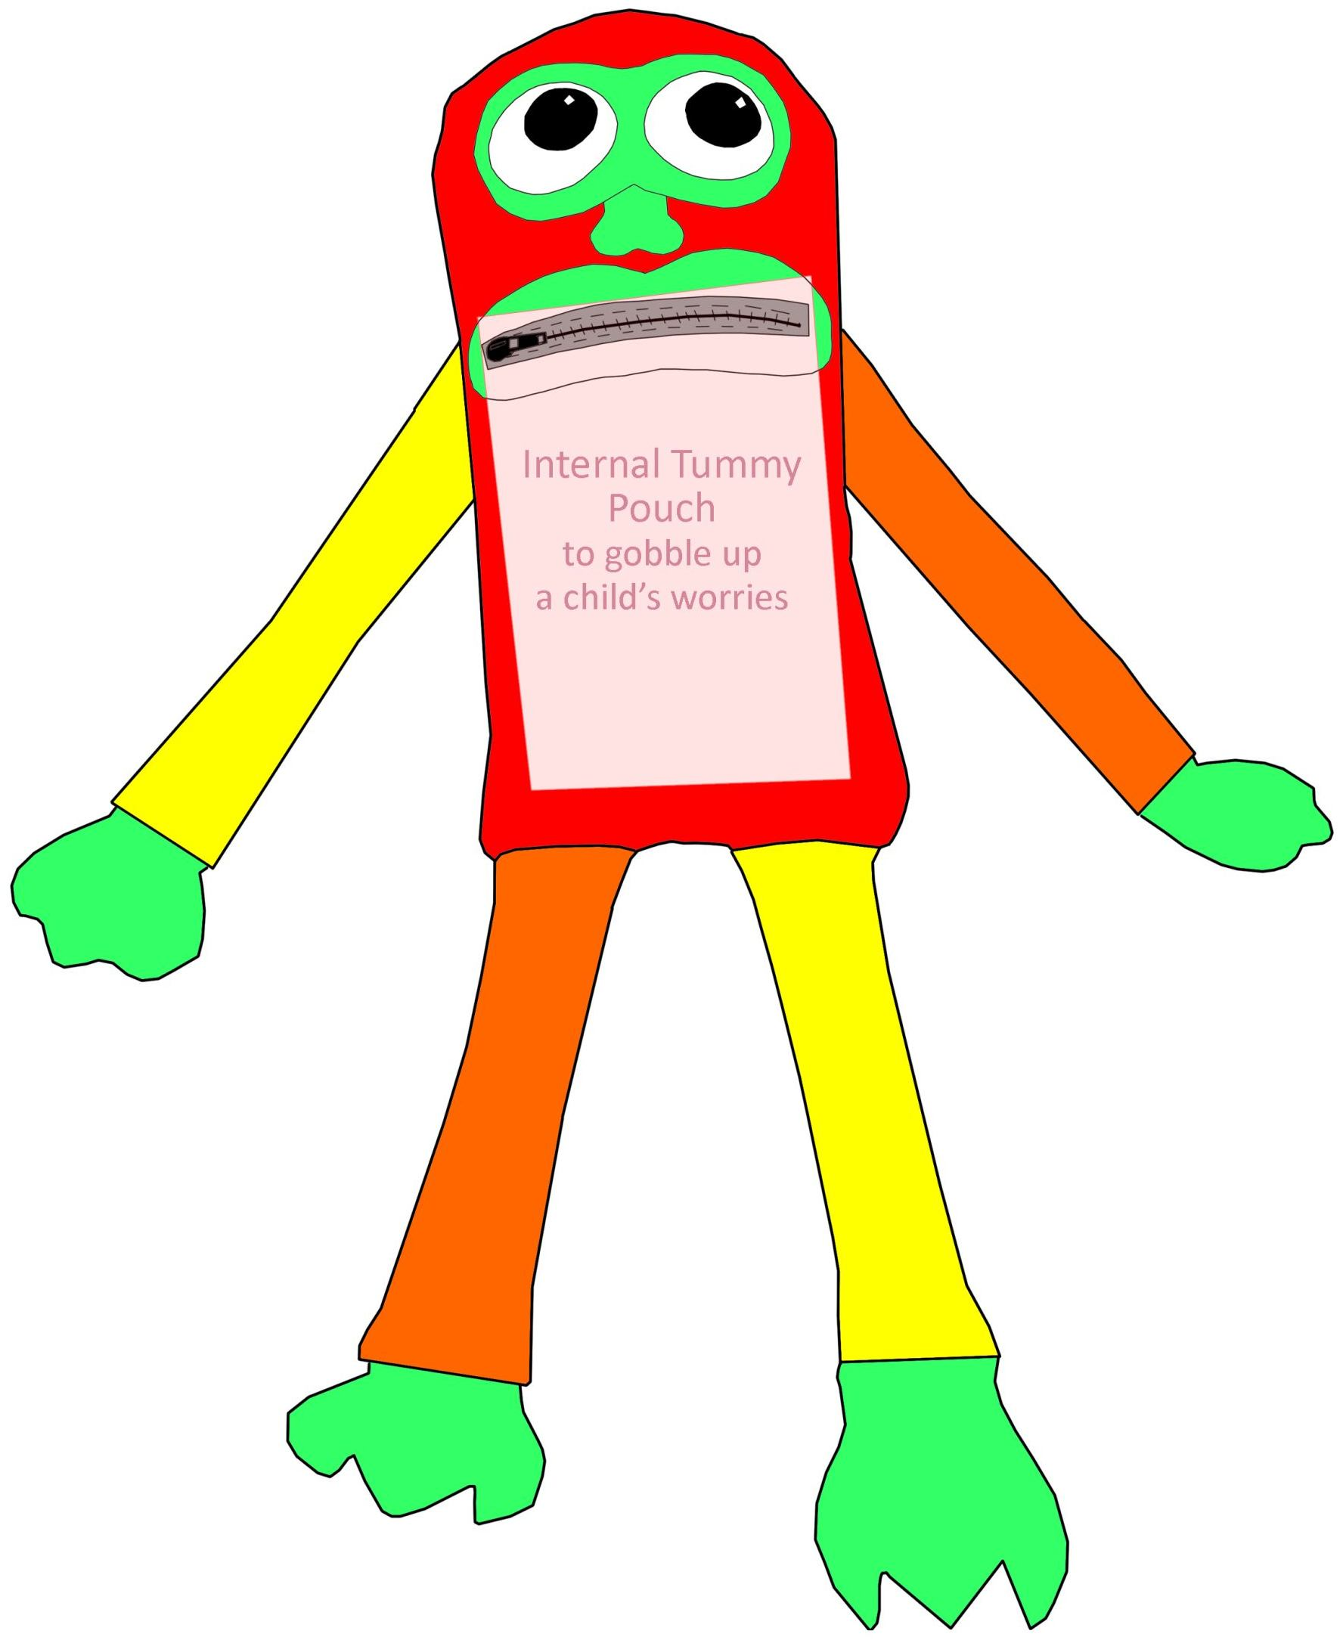
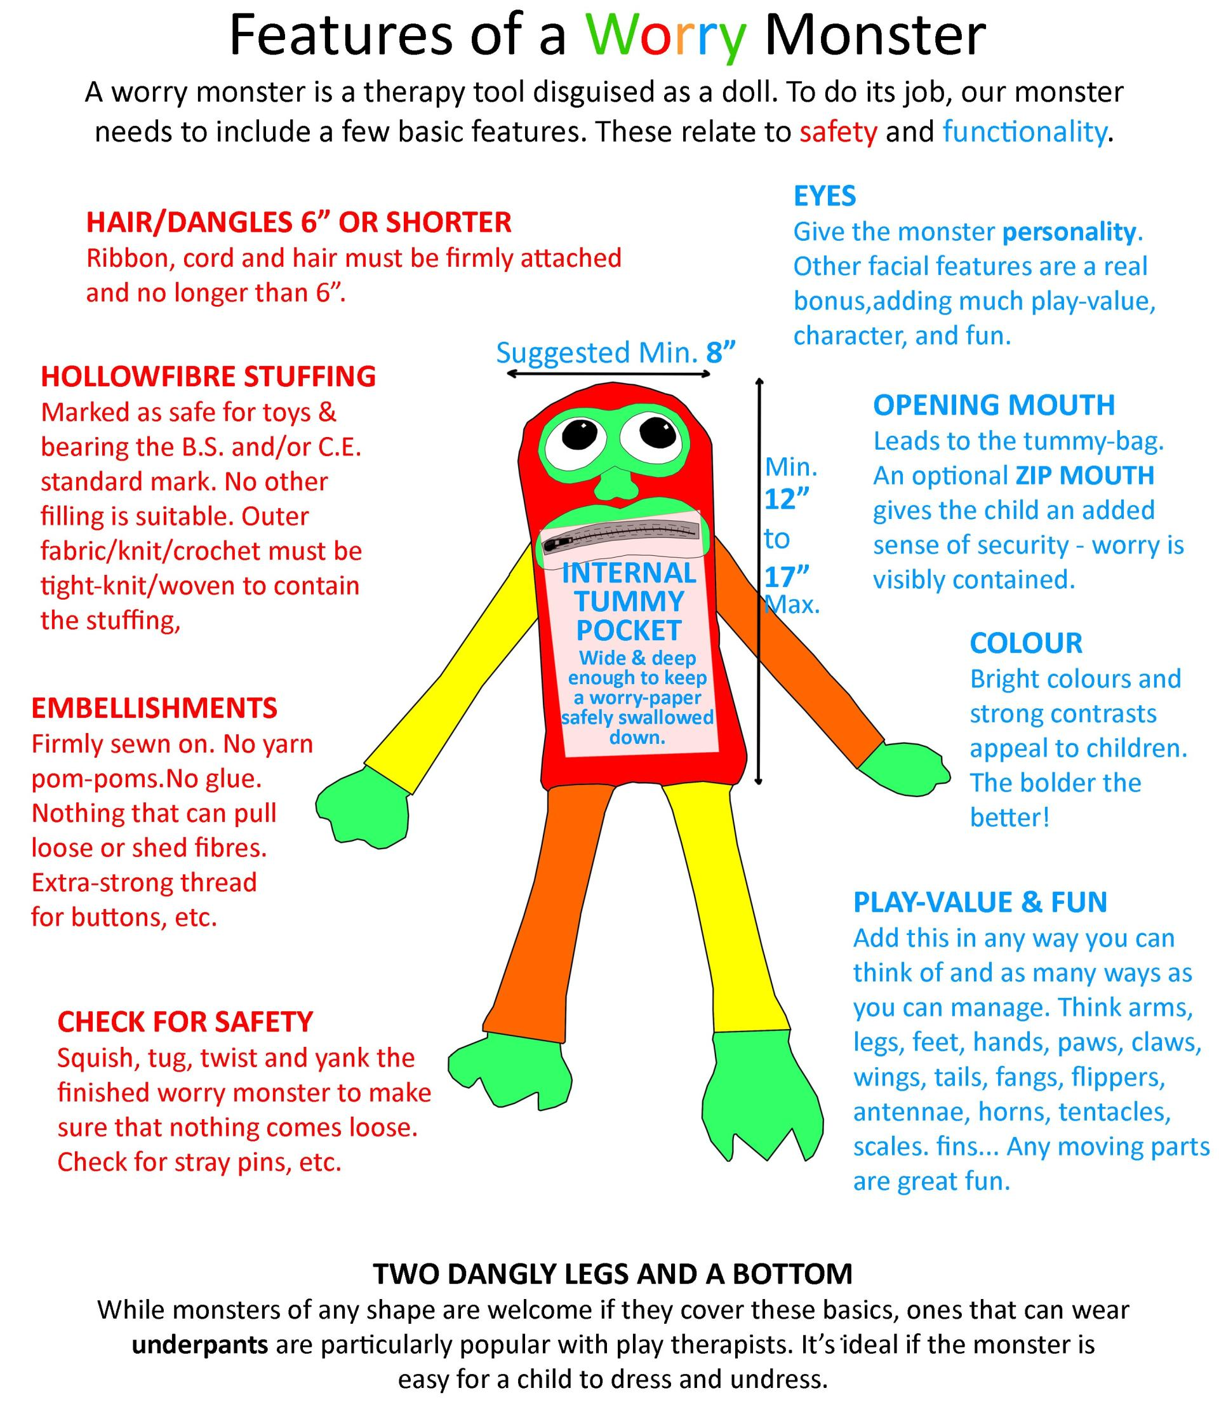

SAFETY
- Filled with hollowfibre stuffing from packaging that is marked as suitable for toys and which bears the B.S. and/or C.E. safety mark(s). No other type of filling is suitable for a worry monster.
- Well-constructed so that seams cannot break/stuffing won’t leak.
- Embellishments and external features like ears, horns, etc., must be firmly sewn on. Secure anything that might fray or unravel and avoid ‘hairy’ yarns which tend to shed fibres.
- No pom-poms – they shed easily.
- Special care must be taken with potential choking hazards such as buttons – use extra strong thread and secure with many stitches.
- No glue to be used.
- Anything that dangles – hair, ribbon, cord, etc – must be no longer than 6” (15cm).
- Take care to remove all pins, etc., from the finished monster.

BASIC FUNCTIONALITY
- A body tall and wide enough to accommodate a functional tummy-pocket. A minimum head/body height of 12” (30 cm) is requested.
- A maximum head/body height of 17” (43 cm) is requested, to fit into Knit-for-Nowt’s shipping boxes. Legs/arms/etc. that fold back over the body can be any size.
- An opening mouth so that a child can feed a worry paper into the tummy.
  - If we add a zip to the mouth, we give the child an extra sense of security when feeding their worry to the monster. It also adds a fun moving part.
- Eyes to give the impression of a face and a sense of character.
- Well-stuffed with hollowfibre filling from packaging marked as suitable for toys and bearing the B.S. and/or C.E. safety mark.

BRINGING THE MONSTER TO LIFE
Building around these basics, we can really bring the monster alive and engage the child’s imagination by adding limbs, facial expression, ears, tentacles, tails, horns, wings, fins, flippers, hands, feet, paws, claws, hair, fangs – any combination we can dream up to add play value, colour, character, and fun. A tiny reflection/highlight in the pupils of the eyes makes a huge difference. Moving parts are great. The more features you can add, the better.

PANTS
Two dangly legs with a bottom is a popular monster shape with play therapists, allowing the child to dress/undress the monster easily with a pair of knitted underwear. Read about the NSPCC’s PANTS: The Underwear Rule campaign here: https://www.nspcc.org.uk/preventing-abuse/keeping-children-safe/underwear-rule/

COLOUR
The brighter and bolder the better! Clashing, madcap colours aren’t only fine, they’re encouraged. Bright colours and vivid contrasts add a lot of fun and a ‘wow’ factor to the monster and help to engage children.
Don’t be afraid to throw in some dark colours for contrast. Primary colours appear extra vibrant against black and/or white.

HELEN’S MONSTER DESIGN
In this guide you may notice that I make up the outer body pieces of my monsters using patchwork. Once sewn together and pressed, I treat the patchwork pieces exactly as I would a single piece of fabric.
This is an adaptable design. I suggest a method and an order of doing things, which I’ve found works well for me. If you can see a way that suits you better, or if you want to build on my design to create your own shape and character, that’s brilliant. My own monsters never turn out exactly the same twice. I keep the basics in mind – min./max. body size, mouth and tummy-pocket, and the safety essentials – and go with the flow, building around them to create a monster that makes me smile. I also work around the many mistakes I make!
This design has a deep enough tummy area for you to leave out the zip if you prefer. I suggest using a non-slippery fabric for the tummy bag if you do so, or if you go with a shorter body. Personally, I find it much harder to finish the mouth area nicely without a zip than with one – the zip fabric provides something very strong to sew the other layers to
If you stick close to my suggested measurements, you’ll end up with a monster head/body about 15”-16” tall and 8” wide, with four silly dangly limbs, a slightly curved ‘head’ and ‘bottom’, and a mouth/pocket just large enough for an adult to put a hand inside. The monster will be able to wear a pair of knitted underpants and be relatively easy for a child to dress/undress.
I stress the safety points throughout this guide. Knit-for-Nowt cannot donate a worry monster that does not meet their safety requirements, which are set on the advice of Trading Standards.
Thank you for supporting such a vital charitable scheme as Knit-for-Nowt with your crafting. Resources like worry monsters make a world of difference to play therapists and the children they support.

YOU WILL NEED

Materials
- Colourful fabric/s for the outside of the monster.
- Colourful felt for the facial features, hands, and feet. Some suggested shapes for the felt pieces are at the end of this guide. They may not print to scale, so I suggest drawing your own templates, or cutting the felt freehand.
- One 5” closed-end zip – chunky is ideal but standard skirt zips work fine.
- Polyester satin lining fabric for the tummy pouch
- Embellishments of your choice – ribbon, rickrack, etc.
- Thread – matching or contrasting for the felt pieces. Extra strong thread if sewing on buttons or other potential choking hazards.
- Optional – fabric to line the pieces if they aren’t stuffing-proof.

Tools and Equipment
- Sewing machine or selection of hand-sewing needles.
- Sharp scissors and/or rotary cutter and mat.
- Ruler (cut freehand if you prefer).
- Small, circular items to draw around for your eye shape/s.
- Pins.

Optional
- Heat-fusible interfacing for felt features.
- Thimble.
- Small quilter’s clips to keep layers from slipping.
- Embroidery thread and tools.
- Pencil or pen to mark fabric and draw templates
- Cardboard or paper for templates.

STEP 1: READ THROUGH THIS GUIDE
While explaining how to make a monster similar to the one pictured, I encourage the reader throughout to make design decisions and go their own way on features, shape and sizing. Please read right through and decide what to aim for before you begin, and especially before you cut anything!

STEP 2: CUT THE FABRIC PIECES

Body
- 2 rectangles of colourful fabric measuring 8.5” wide and 17” long.

Arms
- 2 rectangles of colourful fabric measuring approx.. 3” wide and 10” long

Legs
- 2 rectangles of colourful fabric measuring approx. 3” wide and 12” long.

Facial Features – See end of guide for suggested shapes
- 1 felt piece for lips
- Felt pieces for eyes – suggest layered circles of light and dark felt.
- Optional: 1 piece for felt mask
- Optional: 2 pieces for felt nose
- Optional: Ribbon and/or rickrack to embellish around the eyes/mask.

Hands and Feet – See end of guide for suggested shapes
- 4 felt pieces for hands/paws
- 4 felt pieces for feet/claws

Tummy Bag
- We will cut this piece later when we have fixed the position of the monster’s mouth.

STEP 3: SHAPE THE BODY/HEAD
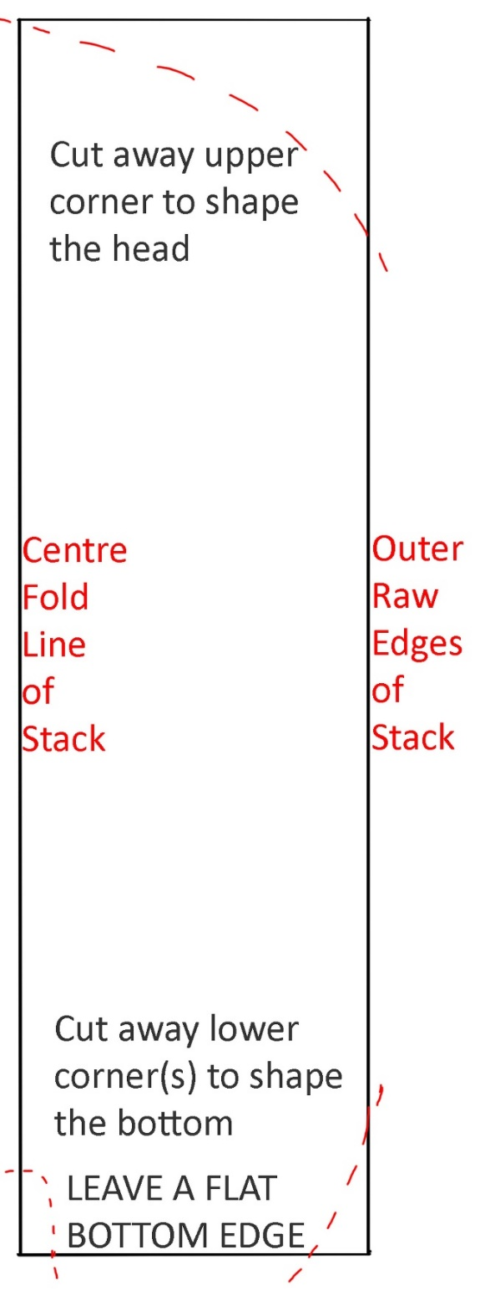
- Stack the body pieces with the edges lined up and fold the stack lengthways.
- Press the stack carefully with an iron.
- Check that the edges are lined up – clip or pin if needed.
- Optional: Press the fold line of the stack to create a crease down the middle of the body pieces. We can use this later to help place the facial features.
- At the head end, round off the outer corner of the stack to create a head shape.
- Optional: At the bottom, slightly round off the outer corner to create a hip shape.
- Optional: At the bottom of the centre fold line, cut a small notch for the ‘crotch’.
- Make sure that the bottom edge of the remaining fabric is a straight/flat edge. (With a curved bottom edge, I find it easier to attach the legs after sewing up the rest of the body.)
- Take the stack apart and choose which piece of fabric will become the front of the body. Set the other aside.

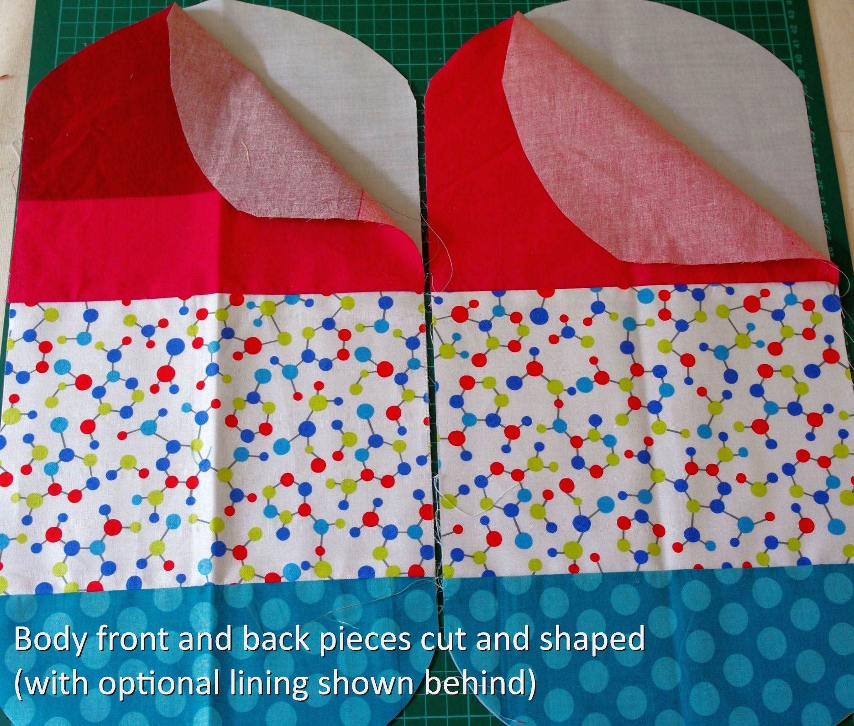

STEP 4: POSITION THE MOUTH
For this step you’ll need the felt lips. The shape is up to you, but the ‘window’ in the middle needs to frame the working part of the zip all the way around, leaving enough space that the zip won’t catch on the felt. My diagram may not print to scale, so I suggest drawing your own templates, or cutting the pieces freehand. For a 5” zip, the hole in the felt lips needs to be a bit more than 5” wide to make room for the zip-pull and the end-stopper. How tall depends on whether you chose a standard or a chunky zip, and how much of the zip fabric you want to leave visible.

- Decide where to place the mouth/zip and pin the felt lips into place.
- Optional: Tack the lips into place.
- Make a 5” horizontal cut between the lips.
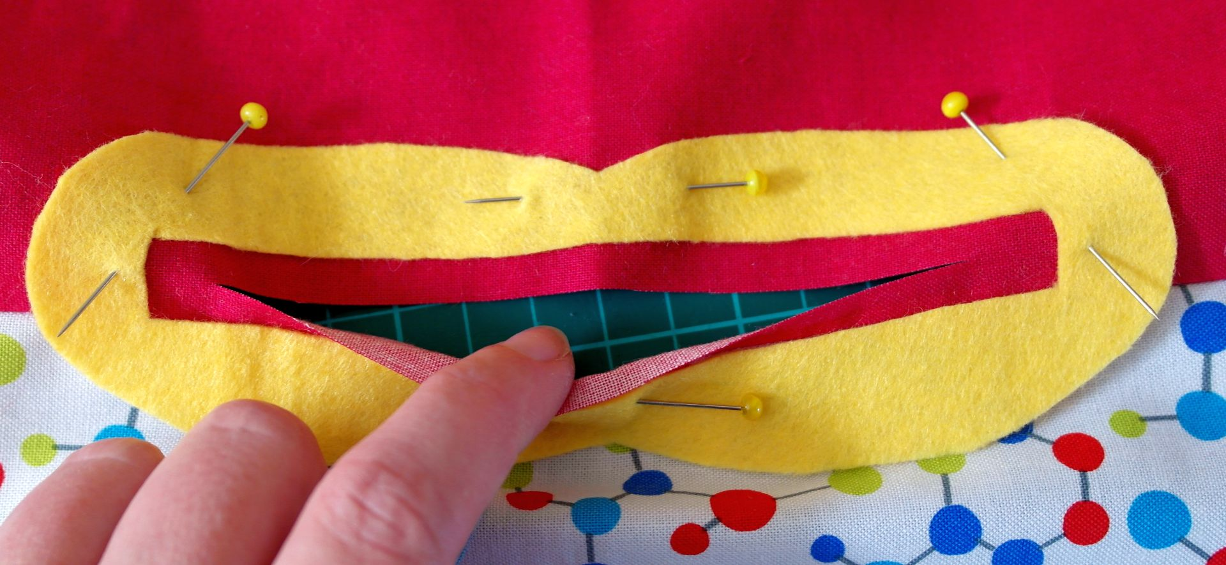
- With sharp scissors, carefully extend the 5” cut behind the felt lips. It should finish about halfway under the felt at each corner of the mouth. It’s important that the raw ends of the cut are well covered by the felt but do not extend as far as the outer edge of the lips.
- Turn the body piece right-side down on a hard surface.
- Carefully make small cuts at each corner of the slit we just cut – we are aiming to create a small flap that we can fold back behind the upper and lower felt lips, and two smaller flaps that can be folded back at the corners of the mouth.
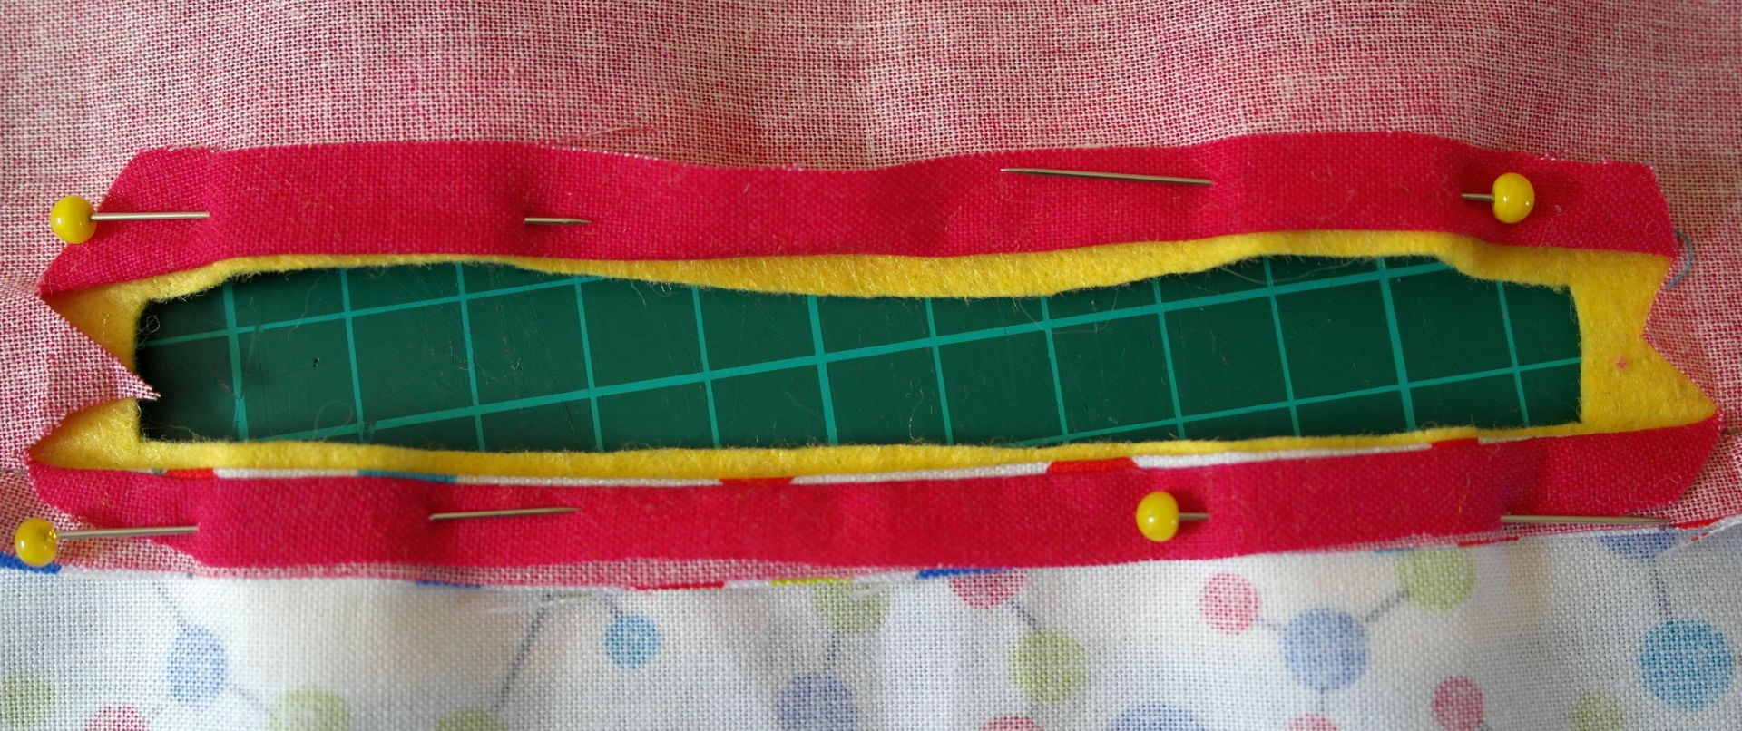
- Press the flaps back with an iron.
- Optional: Sew the flaps down.
- Optional: Reinforce the raw corners with a stitch or two.
- Turn body right-side up and check you’re happy with the position of the lips. You should now have a window in the centre of the felt lips with no fabric visible behind it.
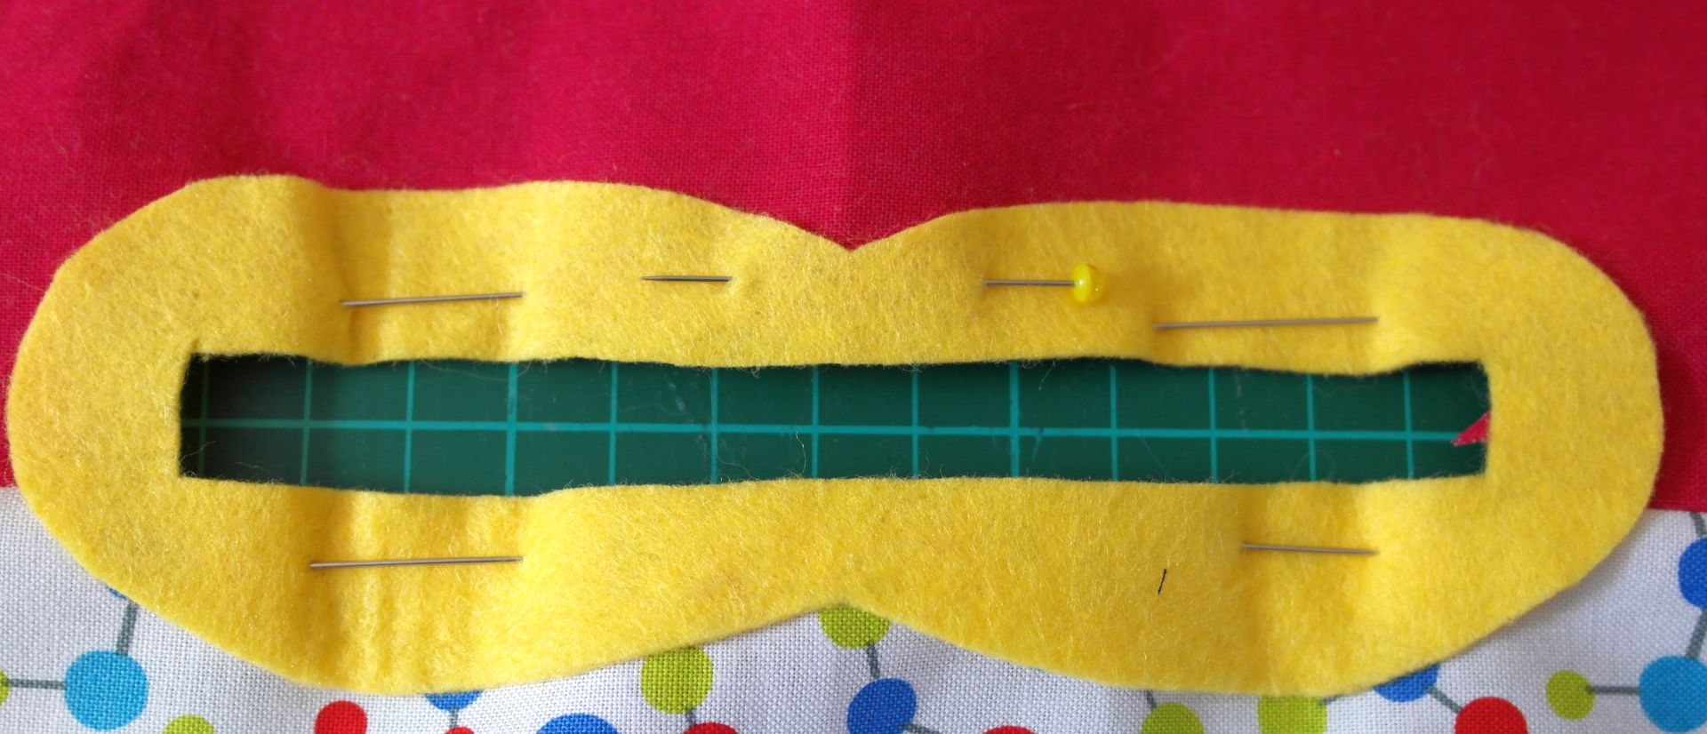
- With thread matching the felt, sew across the top and then the bottom lip, attaching the fabric flap to the back of the felt as you go. I suggest tiny stitches on the outside. The reverse will be hidden so longer stitches here are fine. They don’t need to be too close together – we will go over this area again when we attach the zip, then again when we attach the tummy-bag. If you’re confident (or just more organised than me), you could skip this step and work with the lips tacked or pinned as we set the zip, or even combine adding the zip with adding the tummy-bag.
- Press the whole front body piece with an iron, paying most attention to the lip area.
- Sew around the felt edges. I use tiny hemming stitches that are almost invisible, and sometimes go over it with contrasting machine embroidery. Blanket stitch looks nice too. If hand-sewing, you can leave this step until you’ve set the zip, or even until you’ve added the tummy-bag, sewing through all the layers at once. NOTE: It’s difficult to machine-sew close to the inner edge of the felt lips once the zip pull is in place.

STEP 5: SEW THE ZIP TO THE BACK OF THE FACE
This is a fiddly process but not a difficult one.
Place the zip on a hard surface, face upwards, with the zip pulled completely closed. It will probably be too wiggly to lie completely flat – don’t worry about it.
Carefully place the front piece of your monster over the zip, lining up the zip track inside the frame made by your felt lips. The functional part of the zip, from pull to stopper, needs to be well inside the frame.
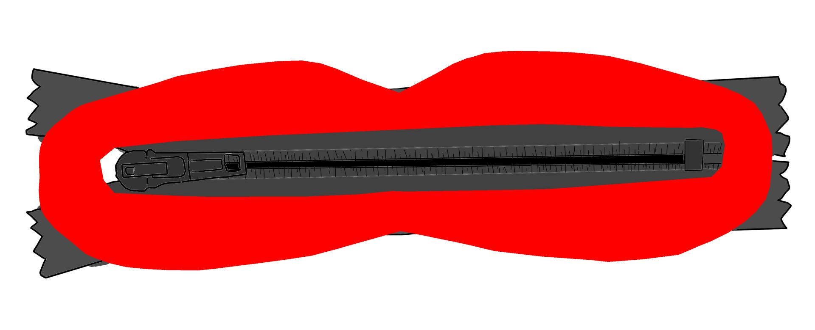
We’re looking to pull the zip taut behind the face while lining up the zip track horizontally between the lips. Fiddle until you have it right then, working from the back but keeping an eye on how the front looks, sew one straight edge into place, smooth things out, then sew the opposite straight edge. Then work your way right around, catching the outer edges of the zip fabric. 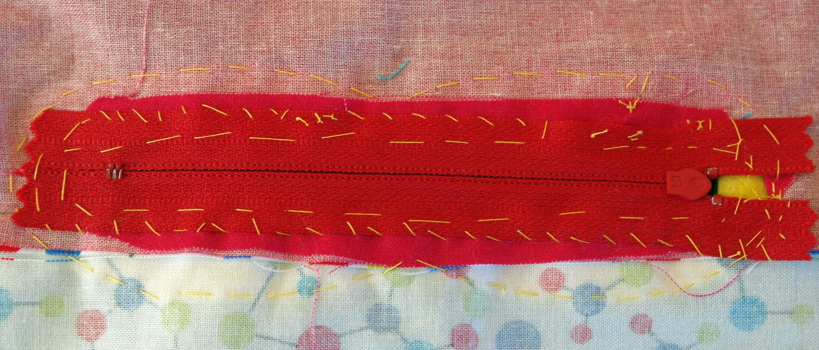
The loose ends of the zip end up hidden behind the body fabric. If we match our thread to the lips and/or the zip colour, any stiches we put here will be hidden once we add the tummy-bag/mouth-lining later, so aim for strong rather than pretty.
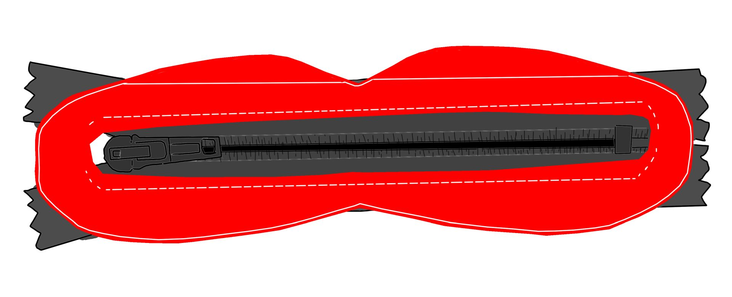
If you didn’t do it earlier, you could stitch around the inner and outer edges of the felt lips now – hemming stitch or blanket stitch would be good – or leave it until you’ve added the tummy-bag later and catch all the layers at once (taking care not to sew the mouth shut in the process!)

STEP 6: PLACE THE OTHER FACIAL FEATURES & SEW
There’s no best method for adding the felt facial features, and anything goes when it comes to your design.
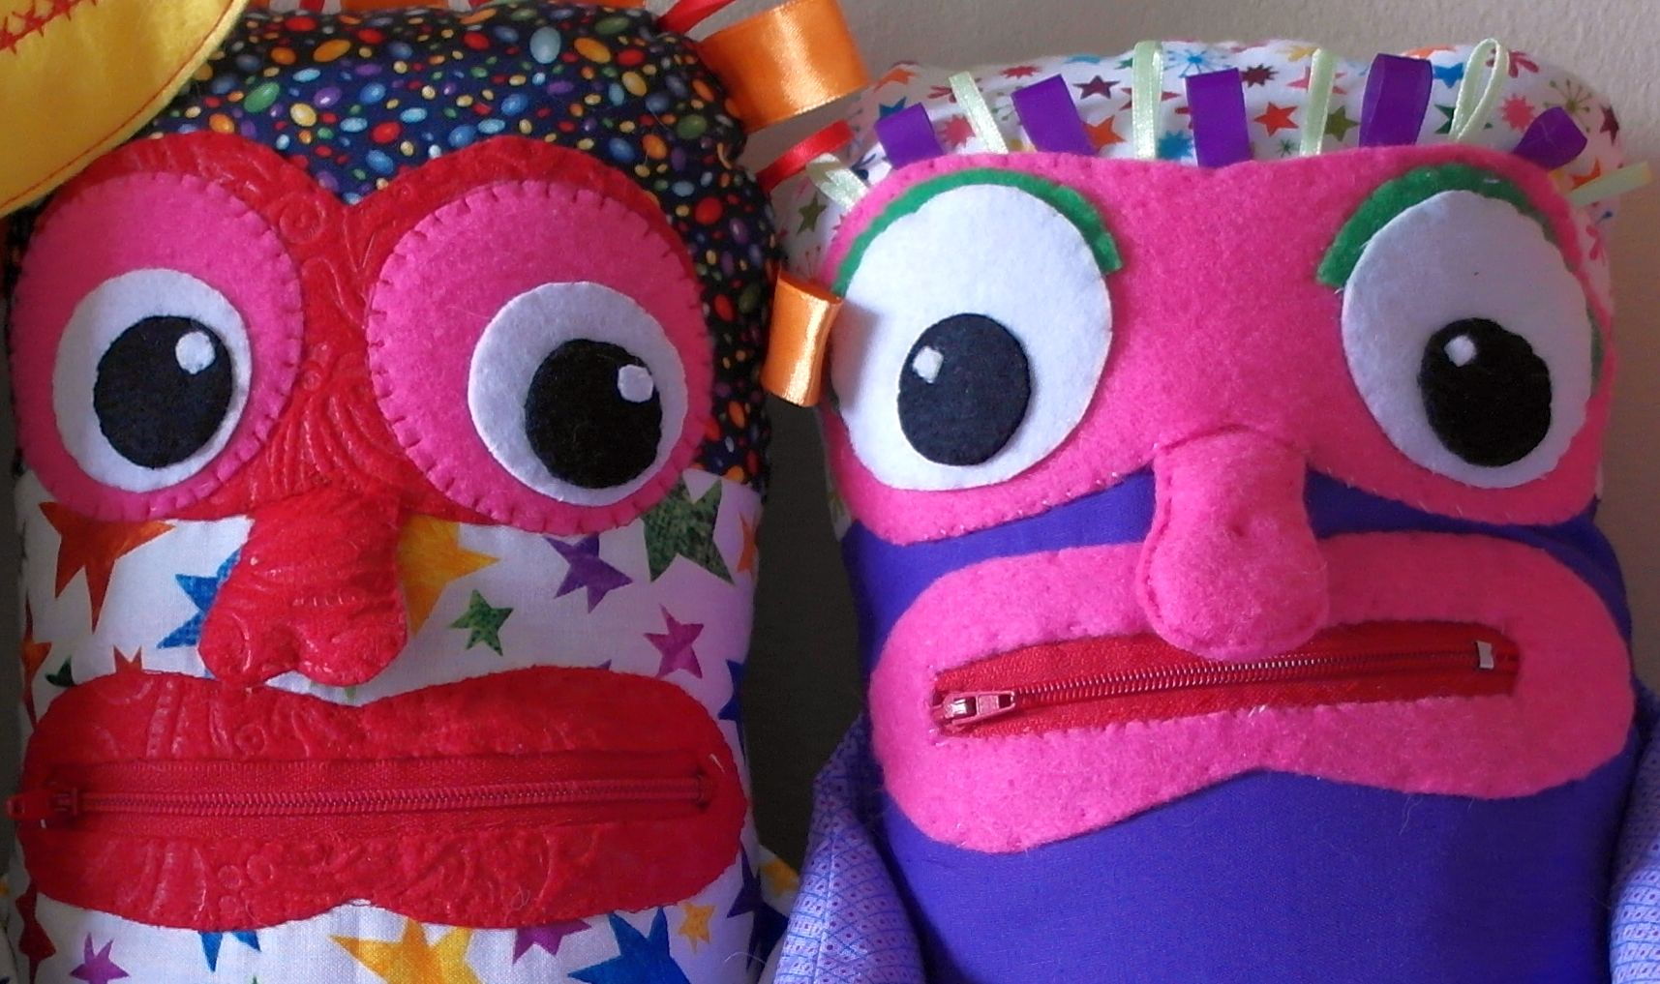
There are a few suggested shapes at the end of this guide and a few photos of my monster faces follow this section. I prefer to fold a piece of felt in half and cut features freehand rather than work from a template. The lips must be tailored to fit around the zip, but the other features can be any shape/size you like.
I sew the features to my front body piece before I sew up the monster, but this could be done later if you prefer. I tend to construct the mask, eyes and nose separately by hand, embellish with ribbon, etc., lightly hand-sew the whole thing in place, then do tiny ‘invisible’ hemming stitches around the edges, by hand, in a matching thread. I sometimes add a decorative machine stitch around the edges afterwards. Hand-sewing a blanket stitch would look nice, too.
If you add ribbon or rickrack make sure that any raw ends are secured against fraying – with ribbon, I put the ends well behind the felt piece. With rickrack, I fold each cut end beneath the felt. If you add any kind of hair it must never come loose, shed fibres, or fray. Anything that dangles must be no longer than 6”.
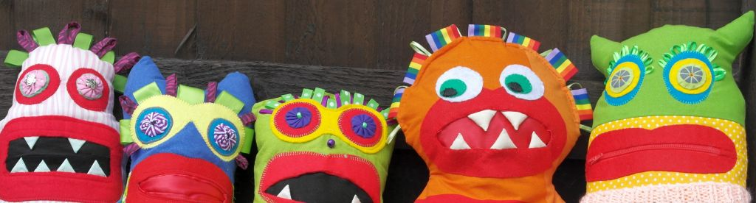
I can’t embroider nicely, so to create the ‘reflection’ in the pupils of the eye I cut out a small triangle, circle, or square of optic-white felt and sew it to the pupil with optic-white thread. I think embroidery looks best if you can do it. If you’re embroidering, why not think about eyelashes, eyebrows – any detail you can add to give the face character.
Two-dimensional features can be constructed and attached with strong heat-fusible interfacing if you wish. In this case, I’d still recommend sewing around the raw edges of the felt to prevent the edges lifting and curling in the future.
Bulky features like a pointy nose, and any features that will sit near or extend across the main seam, such as horns or ears, are best left until after we’ve sewn up the body of the doll – we don’t want them getting caught in the seams as we sew around. If you do add a large facial feature now, make sure that it’s possible to fold it out of the way when we stack the pieces to sew up the body.
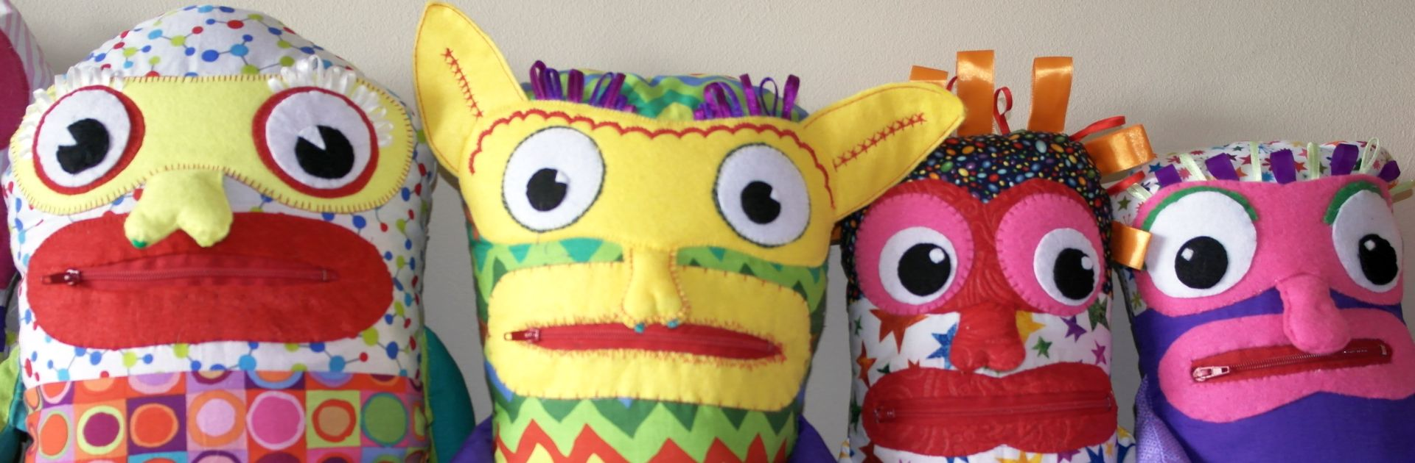
A flatter nose can easily be added now. Mine are lightly stuffed or shaped with felt inserts, then sewn beneath the bottom edge of the felt mask so that they flap loose above the top lip.

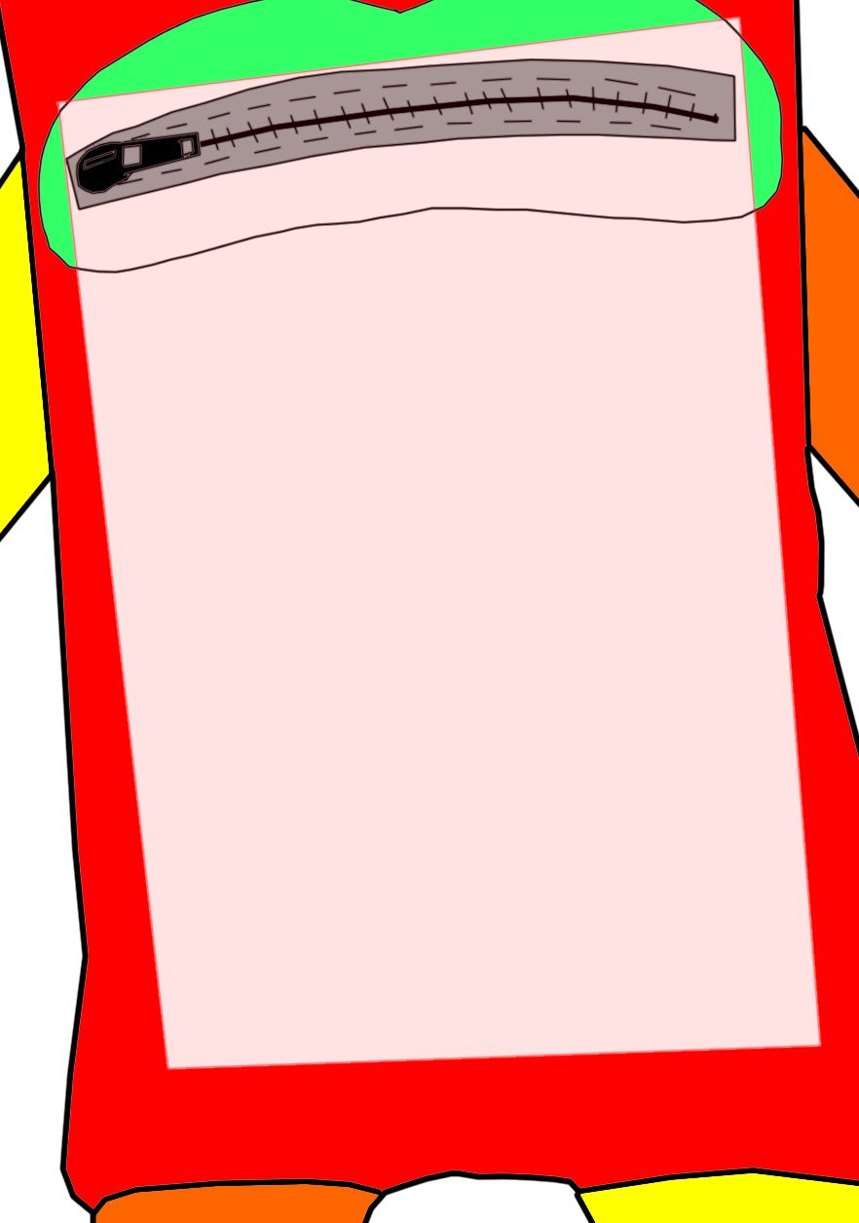
STEP 7: MEASURE AND CUT THE TUMMY-BAG
I use polyester “liquid” satin lining fabric for the tummy-bag. Any non-stretch fabric should work. I find that stretch fabrics are prone to snagging in the zip. I think it’s important that once the monster has eaten a child’s worry, it stays down. If the body of your monster is nearer the minimum 12” than the maximum 17” I suggest avoiding slippery fabric for the tummy – go for something with a bit of grip, instead.
We’re basically making a small bag by sewing up the sides of a long strip of fabric, folded right-side to right-side. The right-side of the fabric will end up on the inside of the bag, with a flap turned outwards at each top edge to create a hem.
Cut a single, narrow piece of fabric – about 8” wide for the 8.5” wide monster body – and fold it in half so that the fold forms the bottom of the tummy pouch.
We’re taking our length measurement from our actual monster – from the top of the lips to near the bottom of the body, plus 2 inches extra for turning the hems at the top.
The measurements don’t need to be exact. Think about where your tummy bag will sit when we layer up the monster’s body pieces to sew them up. It’s fine if the bag’s edges get fixed into the main seam, but if you want to avoid that, shape the bag to fit the contours of your monster.
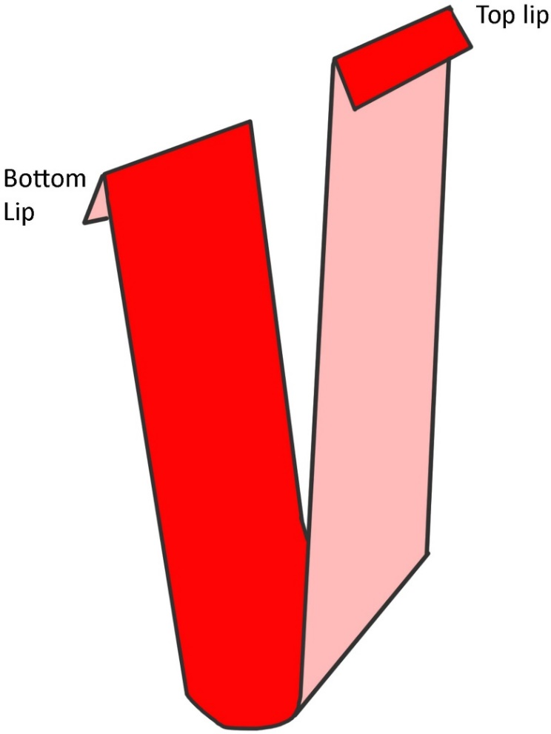
Because the tummy bag is also the lining for the mouth, we need the back of the bag to be slightly longer than the front. The longer back edge attaches to the back of the top lip, the shorter front edge to the back of the bottom lip.
In a monster made from tightly-woven fabric, there’s no need to make the raw edges of the bag’s outside look nice – the seams just need to be really strong. Overlock, zig-zag stitch, or French-seam the raw edges if you want to tame the fraying.
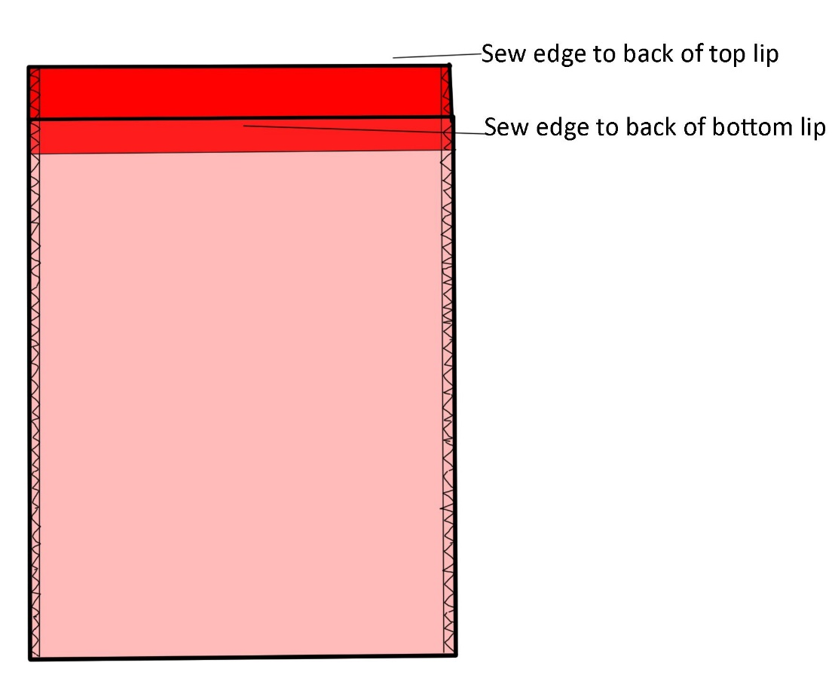

Sew the shorter, front top edge to the back of the lower lip and to the lower half of the zip.
Sew the longer, back top edge to the back of the upper lip and to the upper half of the zip.
Leave enough space between the edge of the fabric and the working parts of the zip that nothing catches.
You may need to play about and do some extra stitching inside the mouth to prevent the satin catching when the zip is pulled, to seal the top edges of the bag firmly to the sturdy fabric of the zip (I recommend tiny hemming stitch in a thread matching either the bag or the zip), and to close up any gaps around the outer mouth area. Don’t be afraid to improvise. A working mouth is more important than a good-looking one.

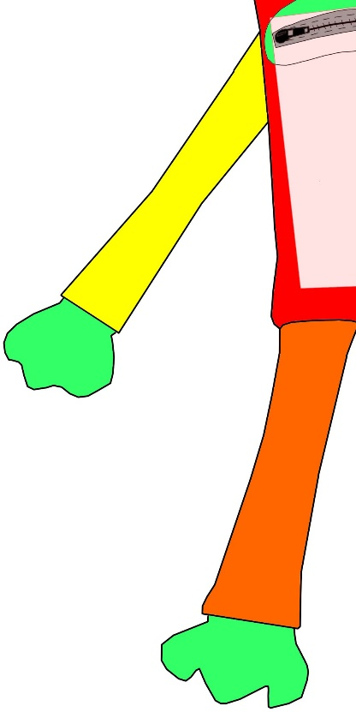
STEP 8: MAKE TUBES FOR THE ARMS AND LEGS
If you have your own ideas for limbs (or tentacles, wings, etc.) don’t hold back. It’s a bonus if the monster is easy for a child to dress with a pair of underpants, which means having legs and a bottom, but other designs are also welcome.
We’re creating four slim fabric tubes, one for each limb. I make my arms slightly shorter than my legs. I usually cut these pieces from offcuts and tailor the length/width to fit what I have available. It’s a good way of using up leftover fabric that isn’t large enough for another monster body or small enough for the scrap bag.
You could cut either 1 or 2 pieces of fabric to make a nice tube. If you use 1 larger piece and fold it lengthways, the single seam can go on the inside of the arm/leg out of sight when we put the doll together. If using 2 pieces, smaller offcuts can be used.
With your fabric pieces for each limb either folded or stacked right-side to right-side, press flat with an iron and sew a straight seam up the raw edge(s). Turn the tubes right-side out then press flat with an iron.
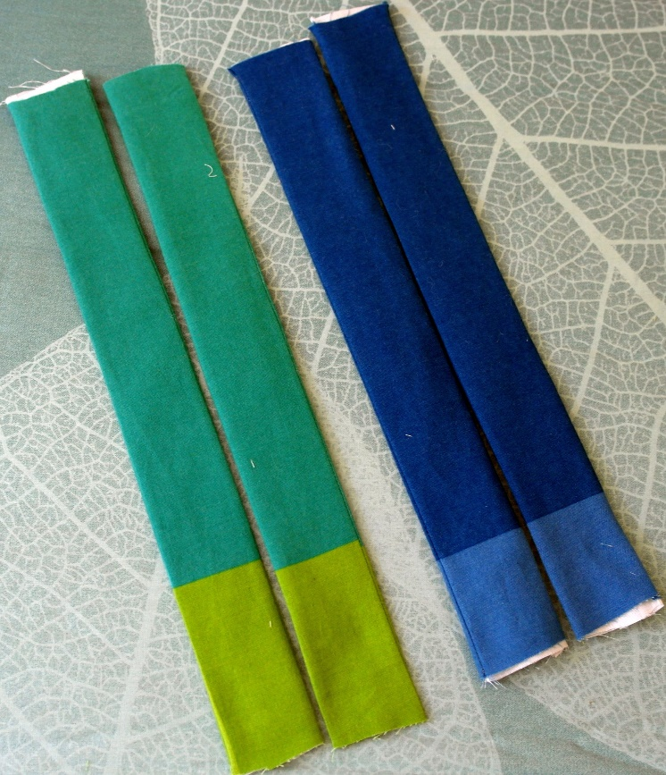
This guide shows the limbs being sewn into the main seam when we sew up the body. Using this method, and especially if placing the limbs at an angle, some of the length of our tubes will be swallowed up into the body of the doll, so we need to allow a bit extra.
We also need to allow a small bit of extra length turn a ‘cuff’ at the end of each tube to hide the raw edge of the fabric before we insert the hands/feet.
I usually opt to make long tubes – between 10” and 14” – and chop some off if I don’t need it. I’ve even made one enormous tube and then cut it into four pieces to become arms and legs.
It’s possible to attach the limbs after sewing up the body. If you go for this option, the top edges of the tubes should be finished as neatly as the side seam.

STEP 9: SEW UP THE BODY
After all those fiddly steps, we’re ready to put our monster together. To get the arms and legs sewn into the seam we need to stop and think about how to layer up the pieces.
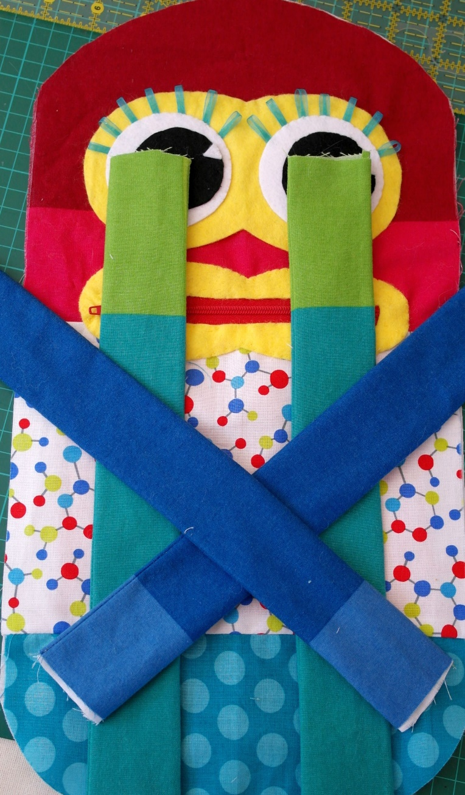
My monster’s ‘feet’ are in front of its eyes, the other end of the legs overlapping the straight edge at the bottom of the body. The arms are crossed over the body so that the ends get sewn into the seam at an angle, leaving the ‘hands’ down at the bottom.
Notice that because the arms are long, the ‘hands’ are quite close to where I will be sewing the main seam around the outside of the body. I need to fold those pieces up towards the middle of the body out of the way. It’s important that the pieces don’t slip once we’ve stacked them in the right order and lined up our edges. Bottom to top:
- Front of body placed right-side up (with tummy pocket sewn behind it and smoothed flat)
- Limbs, overlapping the body edge by at least 1/3 of an inch – more is fine.
- Back of body, placed right-side down on top of layers 1-3.
Take time to line up all the edges, press the stack with an iron, and pin or clip around the whole thing to stop those edges from slipping as you sew. If you’ve added something like a bulging nose, this will tent the fabric layers now. Quilter’s clips really come into their own in this situation, but enough pins will work fine. Stop to smooth things out as you sew if the layers start to slip.
All lined up and pinned/clipped? Sew right the way around the outer edge of the body, leaving a large enough gap to put your stuffing through. There’s space for this across the top of the head, above one arm, or below one arm. You need a bigger hole than you think you do! Sew back over the ends of your stitch-lines where you start and stop – this hole will take a lot of punishment as we stuff the doll and it’s hard enough to sew the gap shut without ripped seams at the corners!
If you have cut your body to my suggested measurements, you have a very generous seam allowance to play with. I like to use the full width of my sewing machine’s presser foot as my guide. If hand-sewing, I go with the width of my index finger.
I’m fortunate enough to be able to do this step by machine, saving a lot of time, but it’s not difficult to sew by hand. These stitches are structural, so they need to be small, tight, and possibly reinforced as you go over the sections with an arm or a leg in the seam. We don’t want any stuffing leaks.
If the outside edges/corners of your tummy bag become trapped in this seam, no problem, but try to avoid catching the bottom of the bag between the legs if you chose to cut that ‘crotch notch’ into your shape. The extra bulk wrinkles an already tricky little curve.
Done? Still got a big enough hole for the stuffing? Great! Trim some of the seam allowance away if you like, but I suggest leaving at least 1/4 of an inch between your stitches and the raw edge of the fabric. Clip the seams if you want to but be mindful of leaving a very strong join.

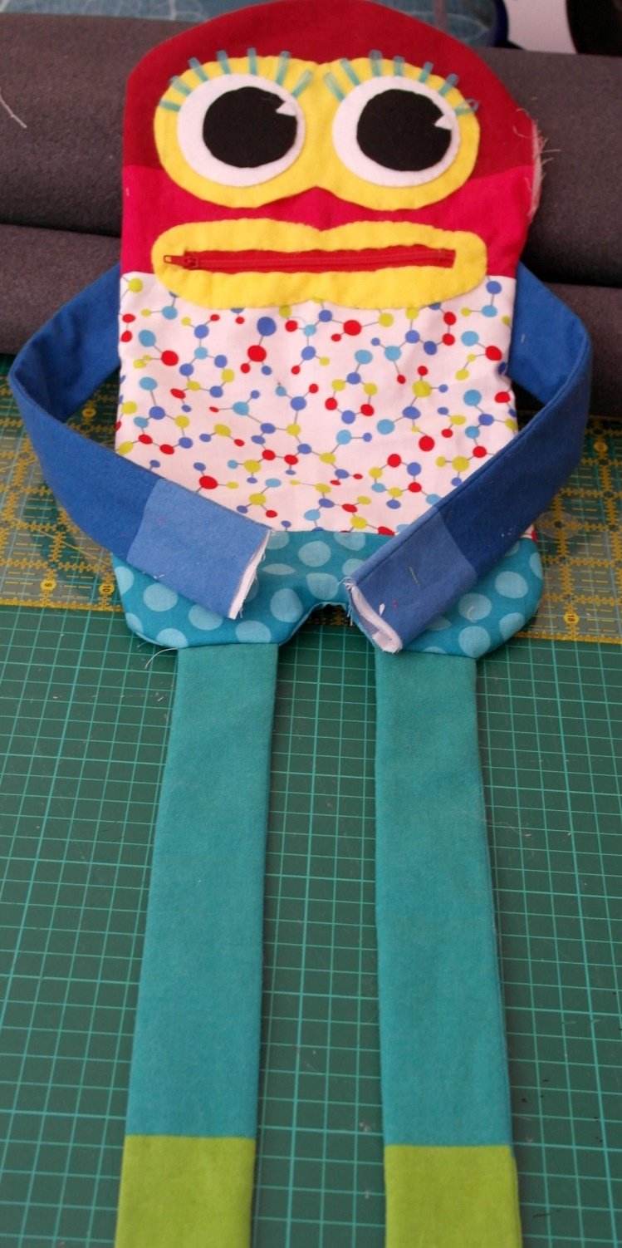
STEP 10: TURN THE MONSTER RIGHT-SIDE-OUT
This step is easy if you left a big enough hole. It’s still possible if you didn’t – just be patient! Be careful if you pinned down your stray arms and legs earlier – you might want to feel around inside and pull out all the pins before you start turning the body right-side out.
Once it’s the right way out, carefully smooth out the seams and press the whole monster with an iron. Take time to work on the seams, and to fold and crease a hem where you will sew the last gap shut.
You can see from this picture that I went with the optional ‘crotch notch’ and left the nose to add later. You can also see that my legs are really long! Fun, but I might chop a bit off before I add the feet. If you’re adding bulky extra features like horns, wings, tail, ears and so on, this can be done now or once the monster is stuffed.
Put your hand inside the mouth and make sure that the tummy bag is fully open and as flat as possible. If the edges/corners of the bag were caught in the main seam then it won’t move about much. If not, it’s possible to pull the bag inside-out through the mouth. (I’m in two minds about whether it’s better to leave it loose or fix it to the lower body/trap it in the main seam.)

STEP 11: TEST ALL THE JOINS FOR STRENGTH
Before you begin to stuff it, take hold of your monster, and give everything a hard tug and a bit of a twist – features, embellishments, seams. Go extra hard on potential choking hazards like buttons and dangles. If anything doesn’t seem strong enough to be permanent and child-proof, go over it with more stitches.

STEP 12: STUFF THE BODY OF THE MONSTER
If you’ve followed my measurements, you’re going to need a fair bit of toy-safe, hollowfibre stuffing to make this monster plump and cuddly. Fill the body little by little and push the stuffing well into the shape.
Don’t stuff the body so firmly that it becomes difficult to slip papers into the tummy-pocket. I usually stick my smartphone in there, poking out of the mouth, before I stuff the monster, to make sure I leave a functional mouth and tummy.

STEP 13: SEW THE LAST HOLE CLOSED
Unless you’ve done this before with a doll or a cushion – something well-stuffed – I suggest that you do some web-searching or reach for a sewing book before you start. Many videos and tutorials can walk you through closing the gap with a hand-sewn ladder stitch or similar ‘invisible’ technique. I use a ladder stitch in thread that matches my fabric, erring on the side of strength rather than beauty. If you have no matching thread, choose a darker shade rather than a lighter one – it will be less visible.
It’s a fiddly job on a firmly stuffed doll. Take your time and concentrate on making a strong join that will never leak stuffing. Leave a tiny gap until the last minute in case you need to add a bit more stuffing. Push extra in with a finger or a pencil if you need it.

STEP 14: STUFF THE LIMBS
Turn a ‘cuff’ at the raw ends of your limb and press with an iron – sew or pin the turn in place if you need to. We’ll be inserting the felt hands/feet/paws/claws into this end of the tube once it’s stuffed.
Add a little stuffing at a time and work it in well so that it fills out the shape of the limb. I like to work the first bits into the corners where the limbs join the body using the sharp end of a pencil, then push more stuffing in with my fingers, wrinkling up the long tube as if I was about to put on a long sock so that I can reach in far enough. The fabric tube will ‘concertina’ down the length of any long stick if you need more reach. Pencil, wooden spoon – whatever works for you!

STEP 15: MAKE UP THE HANDS AND FEET
Other than the fact that the ‘wrists’ and ‘ankles’ need to fit into the ends of your arm tubes, anything goes here. I usually go for something between hands and paws, and either flippers or claws for the feet. All are made from felt, either layered up with some extra felt inside for shaping and sewn through to secure and sculpt them or – if I want to stuff them with hollowfibre– sewn along a template outline drawn onto the felt, trimmed close to the seam, then turned and topstitched.
I suggest that you cut your own templates from cardboard as I don’t know how to get mine to print to scale. Some suggested shapes can be found at the end of this guide. You can draw a shape first or cut freehand. I usually start with a rectangle or square and chop away until I have something I like, then test it against the arms/legs of my monster for a good fit.
I give my feet ‘ankles’ simply by folding them and sewing many times through the fold with strong, matching thread to create a sort of hinge. It’s crude, but it does make felt feet stick out forwards rather than hang limp. I’ve noticed that this works much better on acrylic felt than on softer wool-blend felt.
The felt hands and feet are inserted into the ends of the tubes, behind the hem, then I sew through all the layers once before going right around with ‘invisible’ hemming stitch. It’s possible to create a 3-dimensional wrist/ankle instead of a flat join. Take extra care that the stuffing is unable to escape at the join.

STEP 16: TEST EVERYTHING
Go over your new monster in detail and check everything. Make sure that the stuffing can’t leak, no choking hazards can come loose, nothing frays, nothing that dangles is longer than 6”, and that you’ve removed all sharps such as pins and needles.
Check that the zip works.
Put your hand inside the tummy pocket and check that it’s open all the way down.

CONGRATULATIONS, IT’S A WORRY MONSTER!
Get in touch with Knit-for-Nowt about donating your monster(s).
https://www.knitfornowt.org/contact_us
Thank you for supporting this wonderful charitable scheme. Your monster will make a lot of difference to the lives of troubled children.

©2020 Helen at http://www.inky.work

This guide may be used, reproduced, and reprinted only for charitable and personal use

If reposting/republishing any part of this guide, please link to Knit-for-Nowt (http://www.knitfornowt.org) to publicise their important work.

SHAPES FOR FELT FACIAL FEATURES, HAND/PAWS & FEET/CLAWS
Note: these shapes probably won’t print to scale, which is why I’m not calling them ‘templates’.
